Drones for Tree Trimming

ECE4872 Senior Design Project

Tree Trimmers
Advisor: Dr. James Kenney
Sponsor: Florida Power & Light

Matthew Ramberger, Electrical Engineering, mramberger3@gatech.edu
Nikhil Patel, Computer Engineering, nikhilp863@gatech.edu
Darrell Fambro, Computer Engineering, dfambro2@gatech.edu
Keith Liang, Electrical Engineering, kliang40@gatech.edu
Tyler Bryant, Electrical Engineering, tbryant9@gatech.edu

Submitted

5/4/21
Table of Contents
Executive Summary (5 pts) iii-iv

- Introduction (10 pts) 1-3

  - Objective 1
  - Motivation 2
  - Background 2-3

- Project Description and Goals (15 pts) 3-4

- Technical Specification & Verification (15 pts) 4-5

- Design Approach and Details (20 pts) 5-20

  - Design Approach 5-18
System Overview 5-7
Power System 7-9
Microcontrollers and Bluetooth 9-12
End-Effector Housing & Detachment 12-14
Clamping Mechanism 14-15
Cutting Mechanism 16
Software Design 16-17
Critical Path 17-18
  - Constraints, Alternatives, and Tradeoffs 18-19
  - Codes and Standards 19-20

- Final Project Demonstration (5 pts) 21-22

- Schedule, Tasks, and Milestones (10 pts) 22

- Marketing and Cost Analysis (5 pts) 23-25

  - Marketing Analysis 23
  - Cost Analysis 23-25

- Conclusion (5 pts) 25-27

- Leadership Roles (5 pts) 28

- References (5 pts) 29-31

Appendix A 32

Appendix B 33

Appendix C 34-40

Appendix D 41-43

Appendix E 44-45
Executive Summary
Vegetation such as tree branches or bamboo stalks can potentially grow or fall into power lines causing outages. To prevent outages, the vegetation can be cut ahead of time. The Tree Trimmers team will be developing a removable attachment to a DJI Inspire drone that can cut small vegetation near power lines. The attachment will clamp on to a limb and disconnect from the drone. It will then cut the vegetation using an unexposed saw or a lopper, and the attachment will fall with the vegetation when cut. The attachment will have to clamp on and cut vertical vegetation ranging from +/- 30 degrees and horizontal vegetation ranging from +/- 30 degrees. The attachment will have to be powered enough to cut at least 10 branches of <.50 inches before running out of battery. The attachment will also have to have a signal range of over 200 feet and survive falls of up to 50 feet with no damage to it. A camera will have to be positioned to have proper view of the end effector and vegetation that it is attaching to. Safety wise, the end effector must have no open blades, and the drone must be tethered to prevent a flyaway drone scenario. The attachment, camera, and tether will have to weigh less than 3 pounds total or it will restrict the drone from moving properly.
There have been multiple drones that have been used to cut vegetation which already exist, but overall, they are unreliable and do not meet FPL's required performance specifications. In our design solution, we made a triangular prism frame out of aluminum and attached components such as the clamp and cutter to the frame. We put lexan on two sides of the frame to add durability to the frame and to provide a place to mount. We mounted our soldered breadboard to one of the lexan sheets using bolts and attached our batteries and cutter board to the other sheet using double sided tape. Finally, we added foam to the outside of the two lexan sheets to provide impact resistance. The expected outcome of the design is a working prototype that will serve as a proof of concept for this field. The cost of making this device was approximately $650.42.
We tested our product in three main categories to demonstrate that our solution works: Cutting size, drop height, and signal range. Our cutting size and drop height were mainly successful with some problems once the branch size got wider. There are a few additions that can be done in the future to improve our design. We could add another release mechanism to the side of the end-effector that would allow us to cut vertical branches. We could also upgrade our cutter to one with greater power to allow us to cut wider branches. We also want to implement a PCB design in place of our soldered breadboard with shock absorbent mounting to help provide impact resistance to our electronic components.
Quadcopter Reliability Drone for Vegetation Pruning
1. Introduction
The Tree Trimmers Team developed an end-effector configuration for Florida Power & Light that can integrate with a DJI Inspire Drone in order to perform light trimming and pruning of vegetation. Our team spent approximately $650.42 on our end-effector configuration.
1.1 Objective
The team will design and prototype an optimal end effector configuration that can integrate with a DJI Inspire Drone in order to perform light trimming and pruning of vegetation surrounding power lines. A tethered DJI Inspire drone will contain a securely attached end effector that will approach vertical or horizontal vegetation. Once within close range of vegetation, the end effector will cut vegetation typically ranging between .1-.50 inches in diameter. The end effector will be impact resistant and will be able to withstand repetitive impact with grass and dirt from a height range of 30 -50 feet. In the event the end effector becomes entangled on a piece of vegetation, the end effector will disconnect from the drone, allowing the drone to safely fly away and return to the tethered area.

1.2 Motivation
Florida Power & Light is currently the largest energy company in the United States, providing service to more than 10 million people across the state of Florida. As the world largest generator in renewable energy from the wind and sun, FPL is proud to integrate the latest technology to build a smarter and stronger community. Because of this, the motivation for this product stems from FPL having the vision to implement the use of drones in order to provide safer and more reliable services to their customers in the area of removing vegetation in close proximity to service wire poles. Currently, the process in place requires customers to maintain responsibility to clear any vegetation within close proximity to FPL service wires. In cooperation with FPL, our team is determined to develop a prototype that will deploy to a customers home and clear the impending vegetation. By doing this, our team and FPL desire to introduce a safer option which results in the removal of FPL lineman from the line of fire. We also desire to bring vegetation-pruning contracts directly to FPL rather than customers using third-party arborists.
1.3 Background
Powered by the Smart Grid and Innovation group, FPL has a Florida Power & Light Aerial Intelligent Response (FPLAIR) department which oversees all aerial inspections of the company’s overhead transmission and distribution facilities in addition to multiple solar, wind, and combined cycle power plant sites. The specific use of drone technology in these aerial inspections gave birth to the idea of drone usage in vegetation pruning for customers. Florida suffers from severe weather seasons, with just last year Hurricane Dorian leaving approximately 160,000 customers without power and cost the company $374 million dollars in infrastructure damage [1]. As a result, FPL deployed new “drone in box” technology that can quickly focus on hard-to-reach spots up to 2 miles away, assessing damage in surrounding areas [2].
Known as the “Percepto Drone in Box” solutions, these drones are housed in a base station and dispatched automatically to perform autonomous reconnaissance missions near and around FPL sites. The drones were vigorously tested at Florida International University’s wind tunnel at speeds of up to 150 miles per hour, ensuring that even during storms these drones will prove to be effective. The drones are considered online 24 hours, 7 days a week, available for flight at a moments notice. After completing their missions, they return to their base stations where they are safely housed and charged. Their flight data is then downloaded, so what the drone saw can be analyzed.
Because of the FPL Tariff Agreement approved by the Florida Public Service Commission, which requires customers to maintain vegetation near FPL lines, customers are constantly having to reach out to professional tree clearing services in order to clear debris [3]. The potential involvement of FPLAIR and the drone our team develops poses a solution to this issue and furthermore creates an additional source of revenue for FPL through paid drone tree trimming services.
2. Project Description, Customer Requirements, and Goals
The fundamental goal of the Tree Trimmers team was to design and develop an end effector that will attach to a drone and is capable of performing basic vegetation trimming and pruning capabilities. The design utilizes the existing DJI Inspire Drone with an end effector that effectively cuts vegetation while limiting the impact on flight trajectory. The goals that had to be fulfilled to consider the project a success include:
- Working end effector is created that can interface with a DJI Inspire Drone
- Drone can successfully fly with end effector, attach it to test vegetation, and fly away with end effector in place
- End effector can cut vegetation within specified limits and survive repeated falls onto grass or dirt
- Empirical data analysis to demonstrate functionality and use
The final product created was an end effector prototype that would attach to and detach from the drone with a payload release mechanism, clamp to a branch within 30 degrees from horizontal and less than 0.4 inches thick, and cut the branch and fall with it. Through testing, the end effector prototype was 2.5 lbs, lighter than the DJI Inspire drone’s maximum payload of 3 lbs. It was also capable of surviving falls of at least 40 ft on dirt and grass.
- Technical Specifications & Verification
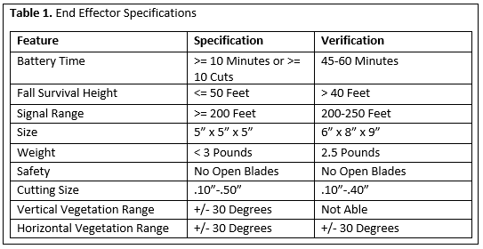
Table 1. Specifications and design requirements for the end effector. These specifications are required by Florida Power & Light.

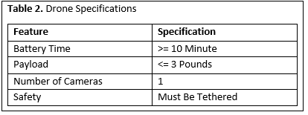
Table 2. Specifications and design requirements for the drone. These specifications are required by Florida Power & Light and the physical restraints of the DJI Inspire drone.
- Design Approach and Details
  - Design Concept Ideation, Constraints, Alternatives, and Tradeoffs
System Overview
The drone end-effector must complete the following functions:
- Clamp to the limb, whether vertical or horizontal. (0-30 degrees and 60-90 degrees from horizontal)
A servo-driven parallel gripper clamp [11] with sufficient clamping force to keep the 2.5 lb end-effector attached to the branch while it is hanging and detached from the drone was used.
- Detach remotely from the drone
This used a servo-driven payload release mechanism to detach and reattach the end-effector to the device at will.
- Allow the drone to fly away
The end-effector was designed to be fully detachable from the drone with no wires or cables connecting the two. This allows the drone to safely get away from the branch once the end-effector attaches to it.
- Cut the limb
This was performed by an on board motor, battery and pruning shear head. We used premade electric pruning shears that already had a motor, battery, and shear head that already worked together in order to avoid the mechanical engineering knowledge needed to design a mechanism from scratch. This option was the only foreseeable path, because of safety regulations given in the scope of work document provided by FPL and the material desired to be cut. (See Appendix C)
- Survive multiple falls from 30-50 feet
A 3D cage shaped like a triangular prism was constructed. The frame was constructed out of light L-shaped aluminum for the outer frame and C-shaped aluminum for the support bars. The cage walls are made of lexan, polycarbonate sheets, and foam padding was added to the outside for better shock absorbance. These factors allow the end-effector to survive multiple falls.
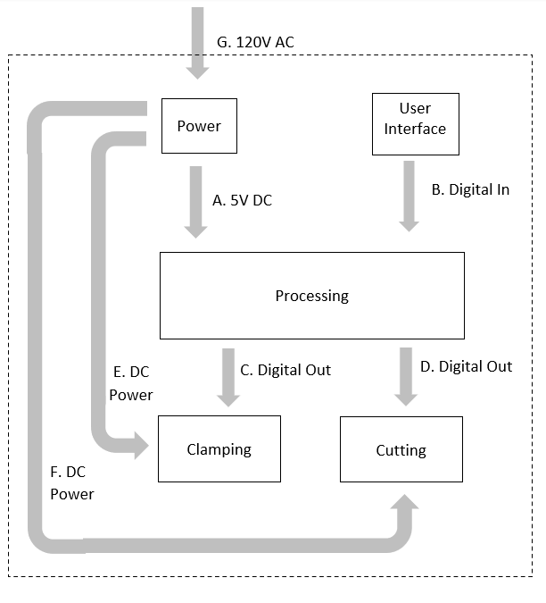
Figure 1. System block diagram of the end effector.
The electrical schematic and board layout created in EAGLE are located in Appendix E.

Table 3. Interfaces between subsystems.
Interface | Description | Source Sub-System | Destination Sub-System
- 5V DC | Microcontroller power supply. | Power | Processing
- Digital In | Digital inputs from push buttons on remote controller received by Bluetooth UART | User Interface | Processing
- Digital Out | Digital voltage signal for controlling clamp motors. | Processing | Clamping
- Digital Out | Digital voltage signal for controlling lopper motor. | Processing | Cutting
- DC Power | Clamp motor power supply | Power | Clamping
- DC Power | Lopper motor power supply | Power | Cutting
- 120 V AC | Wall power for recharging lithium-ion batteries. | N/A | Power

Power System
The power sub-system consists of 3 3.7V 2000 mAh lithium-ion batteries [6]. One battery was directly connected to the nRF52840 microcontroller’s battery input port to supply its power. The remaining two batteries are connected in series to supply 8V DC power, which is be stepped down to 5V DC with a LM7805 voltage regulator. These 8V and 5V supplies both share a common ground with the ground of the nRF52840.
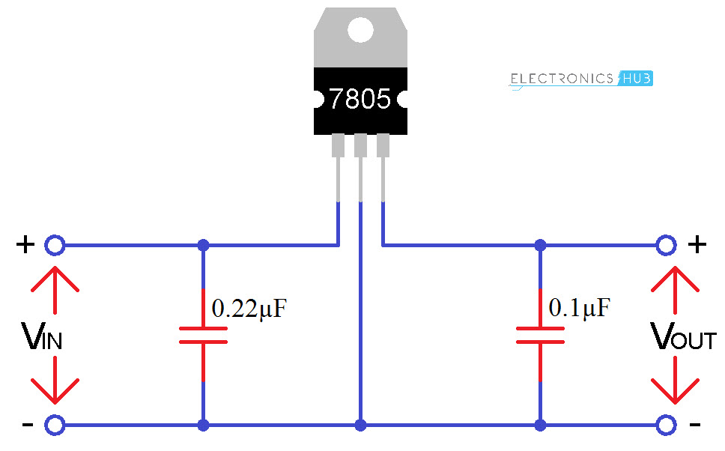
Figure 2. Voltage regulator circuit used. Two 3.7V batteries in series will supply the 8V Vin, which will be stepped down to the 5V Vout.
The 5V DC was used to power both the clamp servo and the release servo. After testing, we concluded that the two servos would never be used concurrently during operation and would draw a combined maximum of 1.4 amps. The LM7805 is capable of supplying 1.5A, enough for both servos in the case that both run at the same time.
Finally, the lopper was powered by the driver circuit board that it was purchased with. This board includes a rechargeable 3.6V lithium-polymer battery already wired to the board. After removing the mechanical switch and safety trigger from the driver board, two 2N3904 BJTs were used to replace them. The collectors were connected to the inputs and the emitters were connected to the outputs, with the bases being controlled by digital voltage signals from the microcontroller, allowing the BJTs to act as digitally controlled switches.
After testing, the batteries were able to deliver enough power to operate the end effector for 45-60 minutes on average, with the lopper motor board battery dying first. During these testing periods, the end effector cycled through its normal operation (clamping, releasing payload, cutting, and releasing the clamp) approximately once per minute.
Microcontrollers and Bluetooth
The microcontroller on the end-effector serves to process the character based command communications from the remote controller and translate them into control signals that manipulate the cutting, clamping, and release mechanisms. To save the time necessary and complexity of developing a PCB to place the microcontroller chip on, a development board from Adafruit was used. This board, the “Adafruit Feather nRF52840 Express” [13] uses the nRF52840 System on Chip (SoC), which combines a microcontroller and Bluetooth Low Energy (BLE) 5.0 compatible module on a single chip [15].
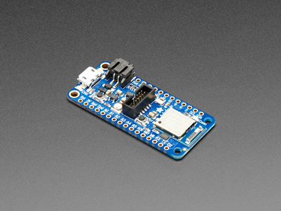
Figure 3. Adafruit Feather nRF52840 Express
Software development on the board was done using the Arduino IDE with Adafruit provided libraries, through the micro-USB interface. A SWD connector is provided for debugging as well. The development board measures 51mm x 23mm and weights 6 grams, meaning it does not occupy much volume or weight capacity on the end-effector. It operates at 1.7 to 3.7 volts, with internal linear and DC/DC voltage regulators. The board has 21 GPIO pins, with I/O peripherals such as PWM, I2C, SPI, UART, timers, and a real-time clock, which made it suitable for application in this project. At 64 MHz, the ARM Cortex-M4F CPU used by the nRF52840 on the board was computationally fast enough for this simple control application and does not consume excess power. Finally, 1 MB of flash was more than sufficient to store the program written for it and likely any future versions.
The nRF52840 SoC on the board uses the MDBT50Q module from Raytac. This is a Bluetooth 5.0 module, specifying working line of sight distances of at least 250 meters at 1MBps and 120 meters at 2MBps in open space [16], which satisfies our constraint of 200 feet (61 meters). Using long range (Coded PHY) mode, it can operate at longer distances at speeds of less than 500 Kbps. In this project we used a 1MBps data rate and found our line of sight communication range to be between 200 and 250 feet through testing. Further improvements to this range could be made by using Coded PHY, but the libraries provided by Adafruit for the nRF52840 Feather Express do not enable this feature. As a tradeoff, Adafruit has integrated the low level BLE stack before-hand, making the board easy to work with. This simplicity and ease of use is why Bluetooth is the preferred communication method over lower frequency RF communications, even though those methods have better range. In the future, an upgrade to lower frequency RF communications can be made, allowing for longer range and more reliable communications.
A major benefit of using this Adafruit product is the ability to use the Bluefruit Connect iOS/Android app with it. This app allows for quick and easy communication with the Bluetooth module, allowing one to use a phone to send characters to the board using UART over BLE. Initially, it was thought that having access to such an application would cut down development time, removing the need to build a controller from scratch. However, this app only allows for communications over a 2MBps data rate, limiting our range to about 120 feet. Thus, another microcontroller was used as a remote controller, transmitting character based commands using UART over BLE. However, the Bluefruit Connect app is still useful as a temporary controller for testing and debugging because the software for the remote controller is yet to be completed.
The microcontroller development board chosen to serve as the remote controller was the nRF52840-DK from Nordic Semiconductor. This board uses the same chip as the Feather Express, but its software is developed using the nRF SDK 17.0.2 directly in the Segger Embedded Studio IDE. This board similarly provides a micro-USB interface for easy programming with Segger J-Link OB programming/debugging support as well. The development board measures 125mm x 60mm, an acceptable size for a board that will be used in a remote controller. It operates at 1.7 to 5.0 volts, with internal linear and DC/DC voltage regulators. The board has 48 GPIO pins, more than enough needed to interface with three buttons for control as described in the software design. This board was selected for a few reasons. First, it uses the same chip as the board on the end-effector, ensuring compatible communications. In addition, Nordic Semiconductor provides extensive documentation and support for both software and hardware facets of this board. Also, being able to work directly with the nRF SDK allows for full control of all capabilities of the nRF52840 chip; more specifically bluetooth communication data rates. Finally, there are numerous code examples provided in the nRF SDK demonstrating the various functionalities of the board, including bluetooth connectivity and UART over BLE. These examples make it much easier to develop custom applications.
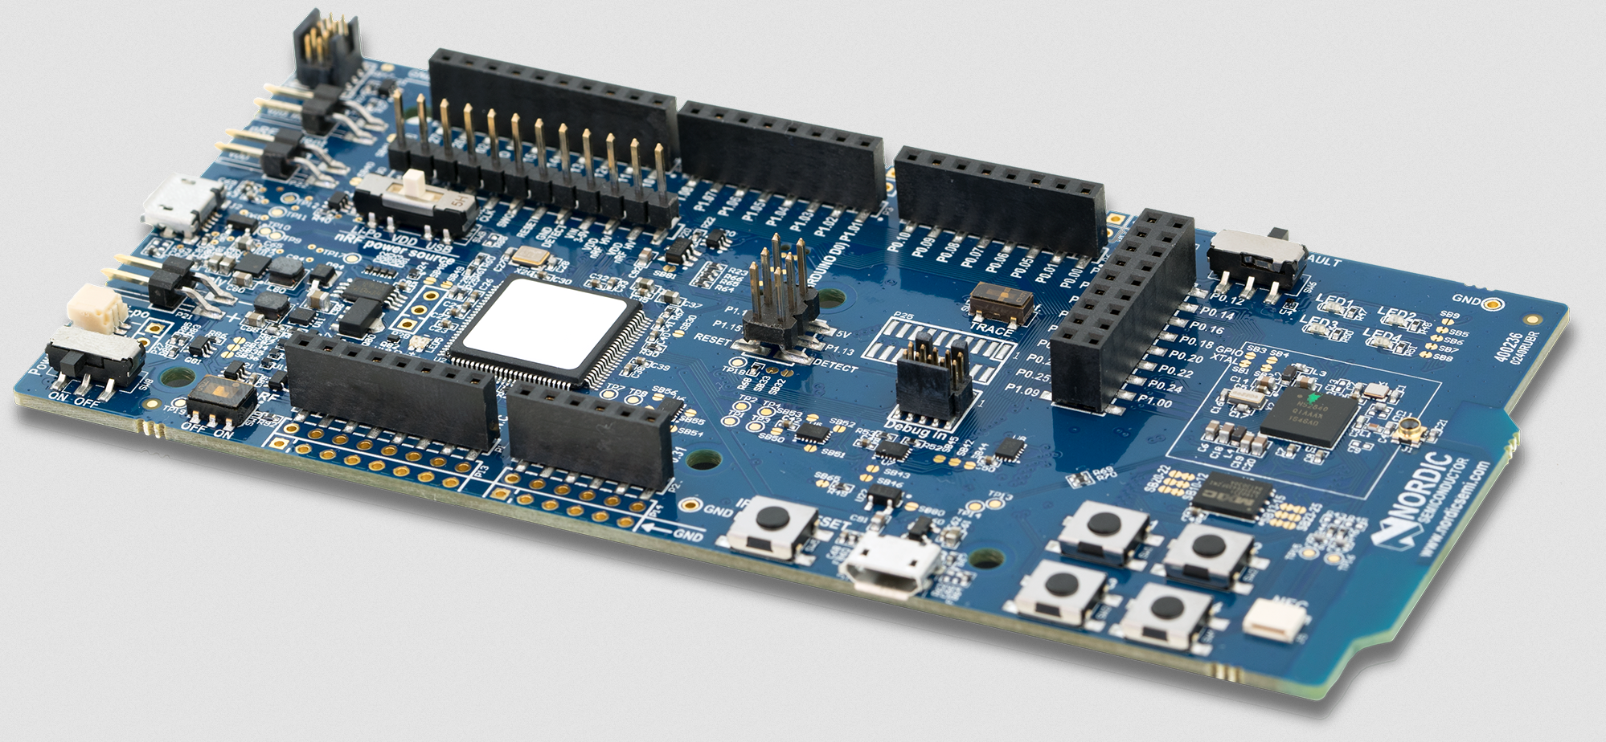
Figure 4. Nordic Semiconductor nRF52840-DK
Another development board that was considered for use on the end-effector was the SparkFun Pro nRF52840 Mini [17], which offers very similar functionality to the nRF52840 Feather Express as it also uses the nRF52840. This development board has much better documentation available. However, the fact that it is not compatible with the Bluefruit Connect app makes the Adafruit board the preferred choice. Overall, the nRF52840 seems to be the ideal choice of microprocessor if communicating between the end-effector and remote controller using bluetooth.
End-effector Housing & Detachment
There are two housings being considered. Drop testing will determine which housing will be chosen for the final design. The first option is to 3D print at Georgia Tech’s Senior Design Labs. The filament we aspire to test with is polycarbonate-ABS alloy. While remaining light, polycarbonate-ABS is a strong material known for its impact resistance. The basic design is a triangular prism with an open bottom for the branch to rest in. The following picture depicts this design.
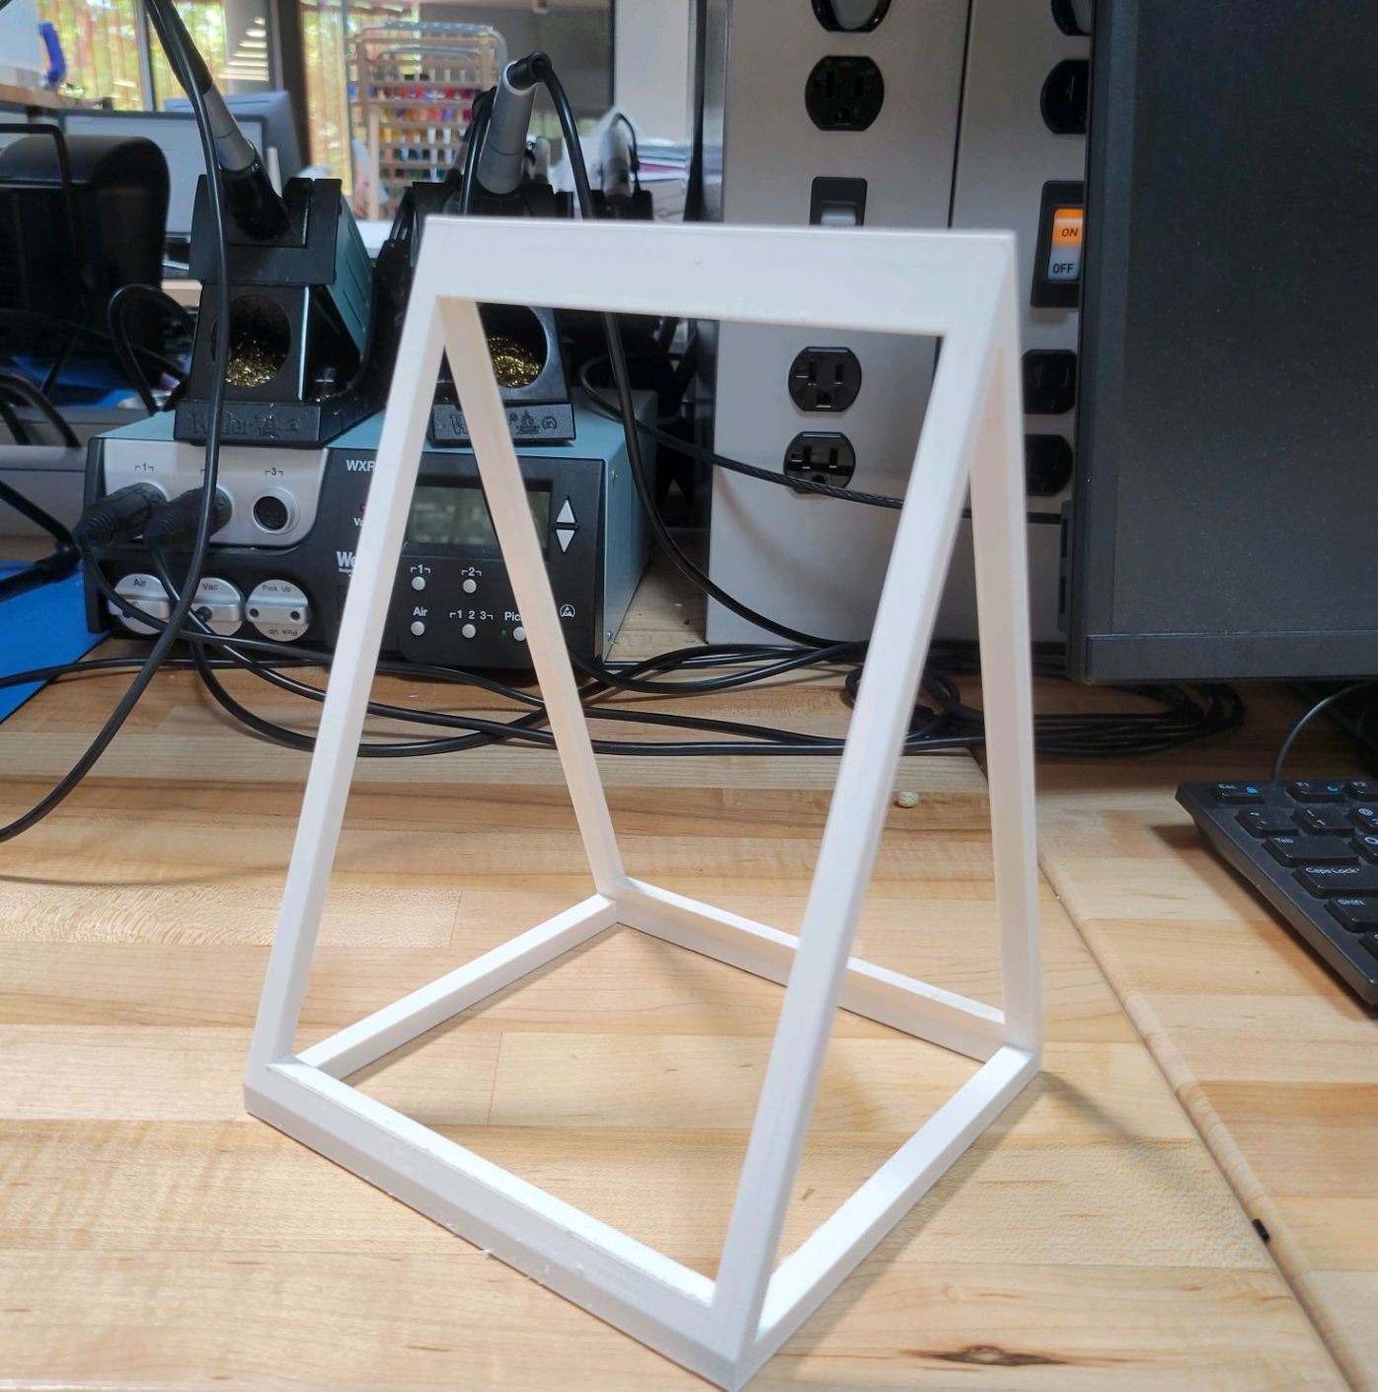
Figure 5. 3-D Printed Housing Design
The 3D printed cage may be difficult without the assignment of a mechanical engineer to our group since it is hard to add support bars to the framing in SolidWorks. The 3D printed frame is also very weak, hard to attach parts to, and would most likely not survive a drop test even with the added support bars. Therefore, we are developing an alternative solution to housing. Ordering pre-cut titanium pieces from a place like Prince Sheet Metal in Macon, GA, Tyler is capable of tig welding the pieces together to generate a box the same shape as the 3d printed design. Before welding the bottom of the box on we will mount the components in the box and fill with foam. This foam and using bushings to mount the components will allow for impact protection on all of the individual components inside the end effector. Flexible Foam by 3M will be used to fill all voids in the cavity. The only caveat is that titanium is relatively expensive.
The final design includes L shaped aluminum rods riveted together to form the frame. The cutter and clamp were attached to brackets made out of C shaped aluminum. Lexan was used to cover the exterior of the frame. All circuit boards were mounted to the lexan. Foam padding was also added to lexan to help cushion fall impact.
There are pre-existing products on the market that allow for remote detachment of a payload with DJI drones. After testing and determining which cage will be used in the final product, an appropriate 3rd party product will be purchased for detachment.
Clamping Mechanism
The end-effector must attach to a branch and disconnect from the drone before it cuts a branch. A clamping system will be used to attach to a branch. The end-effector will cut the branch once attached and fall to the ground with the branch. The clamp will be positioned on the side of the cutting mechanism so the end-effector will not stay attached to the tree once cut. The main clamp currently under consideration is the ACTOBOTICS Parallel Gripper Kit A shown in Figure 6 below [11]. Since small branches down to .10” are being cut, we picked a clamp that didn’t have holes or places that could cause problems cutting small branches.
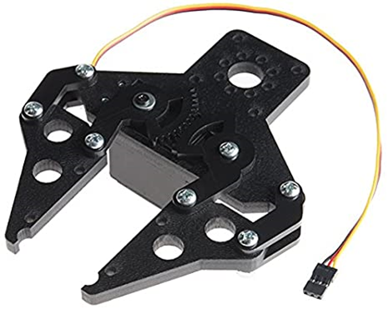
Figure 6. ACTOBOTICS Parallel Gripper Kit
This clamp is very light at 2.15 oz which is important considering the strict weight requirements. It has a maximum width of 2.80” which is more than the maximum branch diameter of .50 inches. This clamp also already has built in servo compatibility which will be required to control it. A servo will have to be purchased to control the clamp. One possibility is the Hitec 31311S HS-311 Servo, which weighs only 1.51 oz [12]. The servo will be powered by our power system described in a section above. In addition, nylon tape can be added to the gripping surface of the clamp to increase friction if needed.
Either one or two clamps can be used for connecting to the tree limbs. Two clamps seem better in theory if all the branches are straight, but most branches have splits or are curved, which can lead to one of the clamps not being connected to the tree or the cutting mechanism not reaching the branch. This could result in the end effector getting stuck on the branch and having to be retrieved manually. Furthermore, two clamps would take up lots of space and weight that we might not have. One clamp should be effective in securely connecting to a branch.
Cutting Mechanism
The cutting mechanism was created by reverse engineering the Ryobi electric pruners. This was accomplished by shorting the safety plates and driving the switch terminals with a PWM wave from the microcontroller. The pruners also have a sensor to determine the open and closed positions. This was mounted to the blade mechanism by cutting the original housing and mounting the necessary part to the mechanism.
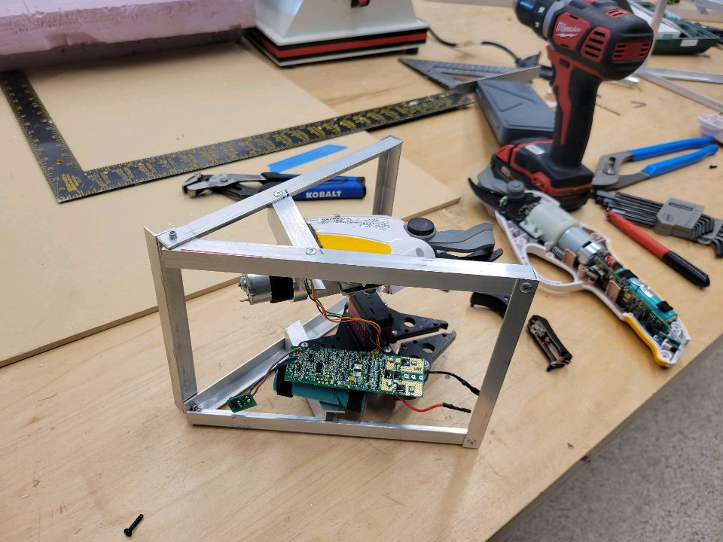
Figure 7. Cutting mechanism showing housing modification.
Software Design
The software design of the remote controller and end-effector follows the software flow diagrams found in Appendix D. The current code can be found on the project Github repo, found linked on the project website. More in-depth details regarding code functionality and pinouts can be found there as well.
The receiver code receives character based commands with UART over BLE and parses them to send the appropriate signal out on the nRF52840 Feather Express' pins. The current command schema is “!T” to toggle the clamp open or closed, “!R” to toggle the release mechanism open or closed, and “!C” to make a single cut. The receiver code will also detect if the tree trimming end-effector is stuck after being released from the drone (i.e. in a tree during normal operation) and has lost connection to the remote controller. After 30 seconds of being released from the drone and clamped, the clamp will automatically open if no fall is detected.
The remote controller transmitter code is a slightly modified version of demo code provided by Nordic Semiconductor [18]. The code is different in that the default configuration is a 1MBps data rate, 8 dBm transmit power, and scanning, trying to connect status. Work still needs to be done to this code in order to enable button interrupts that send the character based commands using UART over BLE. In the meantime, the Bluefruit Connect iOS/Android app can be used to connect to the Feather Express receiver and send character commands over UART. Ideally, as outlined in the flow diagram, the user presses one of three external buttons, each corresponding to a particular command, to trigger an asynchronous interrupt that sends the command using the UART module over bluetooth. Currently, the code is able to establish a long range (200-250 ft) bluetooth connection with the end-effector controller, but it is not able to send characters using UART.
Critical Path
The critical path of this project was the framing. We were not able to get a mechanical engineering student added to our group which meant we were lacking in mechanical engineering parts of this project including the framing. The framing itself took several weeks to complete which prevented us from attaching the cutter and clamp earlier. This set back testing which did not allow us to implement or fix as many components as we wanted.
  - Constraints, Alternatives, and Tradeoffs
The two limiting factors to the design were weight and power. It was observed from available batteries that 2.5 Ah @ 3.7V is available at 43g [6]. The total allotted weight for the end-effector was 3 lbs or 1361g. The end-effector required two geared motors, one to drive the clamp and the other to drive the shears. These 12V motors weigh 184g each, or 368g total [7]. A typical pair of shears also weighs 184g [8]. This put the total weight at 552g, leaving 809g to be dedicated to batteries, framing, and the clamp. The motors required 3 batteries to achieve the desired 12V for the motors. This lowered the total remaining weight to 680g. The application of a pivot joint at the mounting mechanism will account for the displacement of the vertical and horizontal cuts.
A major computer engineering task was to integrate a control method for the end effector. This will require a remote controller aside from the normal one used to fly the drone. An onboard computer is absolutely necessary on the drone, namely the end-effector that will allow it to trim tree branches. The manual aspects of control need to be managed by this computer, in such a way that is reliable and responsive in real-time. In addition, a processor was needed to interface between the human user and tree trimming extension. This means pulling communications data from a wireless communications module and translating them into commands in real-time.
The major tradeoff here is between power and performance. As drones are powered by batteries, they only have limited flight time before a recharge is needed. The DJI Inspire 1 has a normal flight time of 30 minutes. We don’t want to reduce this to under 10 minutes. A high performing processor would be able to handle all of our needs, but at the same time would require more power and reduce flight time. Thus, the goal is to choose a power efficient processor at some determined minimum performance specification.
  - Codes and Standards
- Bluetooth 5.0 - Bluetooth SIG oversees the Bluetooth wireless communication standard. Bluetooth is a protocol that exists to handle bluetooth communications in low power applications, and 5.0 is the latest version. Constraints and usage profiles in the standard, such as data transmission rates, range, and packet size will need to be considered. This will be used to communicate with the end-effector remotely at range.
- Drone is never to be used or tested within 500 feet of any energized overhead power line(s) or other hazardous structures
- The intent of this project is a proof of concept to show that a drone is capable of trimming vegetation. We do not expect or condone the students to actually attempt the trimming of any live vegetation and especially not of any live vegetation near energized power lines.
- All end effector prototypes must be submitted to FPL Liaison Engineer prior to fabrication for safety review and written approval
- Approved design considerations must employ an enclosed or shielded cutting method
- No open saw blades, sharp edges, rotating chains etc.
- Drone and/or end effector prototype must be tethered to a central ground anchor for safety considerations in order to prevent flyaway an establish a safe perimeter zone
- Testing apparatuses must also be submitted to FPL Liaison engineer for safety review and approval
- Approved testing apparatus design considerations must use pre-cut/already downed
- branches purchased from a suitable vegetation retailer and be mounted to a secure stand for testing purposes
- Testing must occur in a large open area free from traffic (both car and pedestrian), energized electrical facilities, and other obstructions
- Testing area must be in accordance with all FAA airspace restrictions
- Drone Operator, team members, and other Members of Public (MOP) should be
- Always restricted to well outside of tethered drone operation radius prior to and
- during testing
- Team must complete a standardized safety review (tailboard) with all person(s) present during testing before setting up testing apparatus and drone
- Team will keep a log of these safety reviews for reference and notify professor of all scheduled testing sessions
- Team will wear proper PPE prior to and during testing including but not limited to:
  - Hard Hat
  - Safety Glasses
  - Closed Toed Shoes
  - Long Sleeve shirt
  - Work Gloves (When handling vegetation, testing stand, and drone)

- Final Project Demonstration
The main deliverables that we demonstrated are listed below. We tested cutting size, drop height, and signal range separately while incorporating several small deliverables like battery lifetime into other tests.
- Cutting Size
- Drop Height
- Signal Range
Unfortunately, we were unable to use a drone in our final project demonstration since the drone we were given had software issues. We had to manually position our end-effector as a result to help simulate a drone.
For cutting size, we first manually held the end-effector over different sized branches at different angles by holding a tether attached to the release mechanism. We then closed the clamp on the branch, released the tether from the release mechanism, and cut the branch allowing the end-effector to fall with the branch. We did this for multiple different sized branches to test the cutting size of the end-effector. An example of this can be seen in Figure 9.
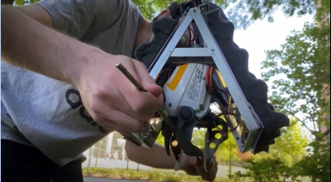
Figure 8. Cutting Size Demonstration
We found that our end-effector could consistently clamp and cut branches from .10”-.40”. However, thicker branches over .40”, the end-effector could not constantly cut with it sometimes taking multiple cuts to cut the same branch.
To test the drop height of our end-effector, we first made an identical frame that was going to be used for drop tests. We did not use our main end-effector for the drop test since we were not sure if it would survive or not and did not want the internal devices to be damaged before we turned it in. We strapped three pounds of weight to the drop test frame and then dropped it from two different heights of 20 and 40 feet. We were unable to find a drop test location higher than 40 feet. The framing survived both drop test heights with no damage to the frame at all. However, dirt from the impact did get inside the frame which could potentially mess up some of the electronic components of the end-effector.
Finally, to test the signal range, we went to an open field and walked away from the controller with the end-effector until it lost connection. We found that the maximum signal range was somewhere from 200-250 feet depending on the line of sight from the controller and the conditions we were in.
- Schedule, Tasks, and Milestones:
The Gantt chart in Appendix A lists the tasks that will be completed, along with their schedules and owners. Each task has been allotted time proportional to its estimated difficulty.
The PERT chart in Appendix B shows the order in which the tasks will be completed in. The critical path is highlighted with red arrows. The tasks along this path are predicted to be the riskiest and most time consuming because the team members have limited experience with robotics design and programming necessary to build a mechanism for positioning the end effector.
The physical design of the end effector and drop testing was completed a week before the expo to provide time for final operation testing and improvements.
- Marketing and Cost Analysis
  - Marketing Analysis
This project is not intended to produce a marketable product, rather it is to create a proof of concept of a tool that will potentially be used by FPL internally. Therefore, it will not be sold, as it’s already owned by FPL. Outside of personal projects, there is nothing on the market or used industrially like what this project aims to create, a tree trimming drone. While there are plenty of drones out there, none have the additional capability of trimming vegetation. As such, this project is looking to lay down new groundwork.
  - Cost Analysis
The total material cost for a prototype of the drone end effector is approximately $650.42. A breakdown of the material costs of the prototype is shown in Table 4. The mechanical parts and motors used to drive them make up most of the expenses.

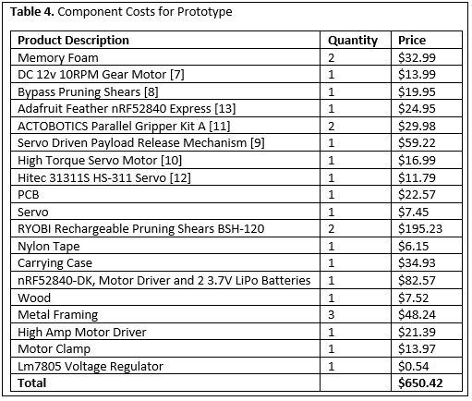
The development costs shown in Table 5 were determined using an assumed labor cost of $40 per hour and approximate part costs from Table 4. The testing and debugging portion will have the highest number of labor hours due to the complexity of the system’s hardware and mechanical parts, as well as the precision required to accomplish the drone’s task.

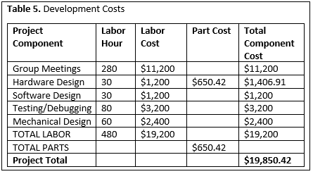

Using the fringe benefit as 30% of total labor and overhead as 120% of material and labor, the total development cost for the end effector is $55,776, shown in Table 6.
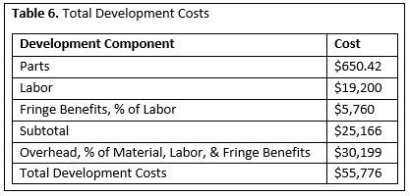

- Conclusion
Some of the biggest hardships we faced were due to the Ryobi cutter. Without being able to read and comprehend any of the documentation on the product, it was difficult to reverse engineer and even gimmicky at times. We were able to find ways to work around it’s quirks, but it should not be used in future iterations.
While the prototype was successful in meeting or exceeding most design specifications, as shown in table 1, this project is not nearly complete. There are many innovations and improvements that can be made.
Additional Release Mechanism
We are currently only able to cut horizontal branches and as specified earlier, we need to cut vertical branches as well. This is an easy fix that can be done by attaching another identical release mechanism to the side of the end-effector. This way, the end-effector can be attached to the drone using either release mechanism depending on if a horizontal or vertical cut is being done.
Furthermore, the release mechanisms could be implemented inside the framing to help them survive impacts. Currently, the release mechanism is at the top of the end-effector on the outside of the frame. They could be attached inside the frame with a small cutout being made in the frame where the release mechanism connects to the drone. This would allow the frame to protect the release mechanisms.
PCB
We already tried using a PCB in our current solution. However, the PCB we ordered had an issue that we could not fix in time, so we used a soldered breadboard instead. A PCB would allow everything to be connected better allowing them to work better and more constantly. A PCB would also survive impacts better since more parts are wired together inside the board. A big worry is that the electronic components will not survive on impact, and a PCB can help solve this problem.
Increased Diameter and Cut Potential
Currently, our cutter struggles to cut larger branch diameters over .40”. This is most likely due to the fact that we used the cheapest cutter available. Upgrading our cutter to a better quality and more expensive cutter can help cut higher diameter branches more consistently. Also, there is only about an inch gap to fit the branch into the cutter. It could potentially be hard for the drone pilot to manually get the branch inside the cutter. Increasing the size of the cutter could help fix this problem.
Shock Absorbant Mounting
As stated earlier, a big worry is that the electronic components will not survive on impact and will degrade after multiple drops. Using shock absorbent mounting when attaching the boards to the lexan can help relieve some of the impact force off the boards and make them more likely to survive.
Titanium Framing
Even though our aluminum framing survived our drop tests at 20 and 40 feet. There is no telling how the framing will look after a few hundred drops. A titanium frame would be stronger and more durable while still weighing about the same as the aluminum frame. This would allow the end-effector to survive more drops. However, titanium is more expensive and harder to cut and weld which means we would have to contract someone else to build the frame which would cost significantly more money than we used for the aluminum frame.
Increasing Payload Capacity by Upgrading Drone
We are currently using the DJI Inspire 1 drone which has a payload capacity of 3 lbs. Our end-effector currently weighs around 2.5 pounds which does not give us much room to add components to improve our design. Upgrading our drone to increase our payload capacity can give us more room to add improvements to improve the overall quality and performance of the end-effector. If we were to upgrade to the DJI Inspire 2, for example, we would have a payload capacity of around 10 pounds, which is over 3x as much as before.
Improving the Clamp Grip
While the current clamping mechanism is capable of supporting the 2.5 lb end-effector when clamped to a branch, there are many things that can be done to improve the grip of the clamp to ensure this is the case for any situation and weight. When clamping to a branch, the current parallel gripper doesn’t have much surface area contact with the branch, massively reducing the clamping force. One approach would be to add another clamp to increase the gripping force. Another approach would be to replace the clamp altogether with a custom clamping mechanism. A third approach would be to modify the current clamp by making the contact surface more concave to make it contour to the circular branches better. In addition, conformable high friction material such as memory foam could be added to the clamp’s contact surface. This would allow for greater surface area contact with any branch because the material would conform to any particular branch diameter when clamping.

- Leadership Roles
Nikhil Patel - Software Lead during ECE 4871, as well as Documentation Coordinator once ECE 4872 begins. Responsible for directing the development of team software, including setting up version control. Also responsible for ensuring all documentation is satisfactory and delivered on time during ECE4872.

Matthew Ramberger - Testing Team Lead during ECE 4871 and ECE 4872. Responsible for safely testing the end effector, measuring the performance of the drone and end effector, and coming up with solutions to problems found during testing for the project.

Darrell Fambro - Document editor for 4871, as well as Web Editor for 4872. Responsible for the review and editing of all documentation before submission. Also responsible for the design and implementation of the website detailing our project during 4872.

Keith Liang - Hardware Team Lead during ECE 4871 and Design Team Lead during ECE 4872. Responsible for management of hardware and mechanical design of end effector, positioning mechanism, and additional attachments to the drone.

Tyler Bryant - Director of Communications during ECE 4871 and ECE 4872, and Expo Coordinator during ECE 4872. Responsible for communicating team plans with FPL (industry) contacts and faculty advisers. Also responsible for making arrangements to demonstrate the prototype end-effector at the 2021 Capstone Design Expo.

- References
- M. McNabb and Miriam McNabbMiriam McNabb is the Editor-in-Chief of DRONELIFE and CEO of JobForDrones, “Drones in Hurricane Response: Florida Power and Light to Deploy Percepto's Sparrow,” DRONELIFE, 16-Jul-2020. [Online]. Available: https://dronelife.com/2020/07/16/percepto-drones-in-hurricane-response/. [Accessed: 13-Nov-2020].

- M. Kenyon, “'Drone in a box' technology provides Florida Power & Light easier way to assess infrastructure,” Treasure Coast, 20-Feb-2020. [Online]. Available: https://www.tcpalm.com/story/news/2020/02/19/fpl-drone-box-another-tool-check-plant-infrastructure/4760778002/. [Accessed: 13-Nov-2020].

- “Florida Public Service Commission,” AssociatedDockets - Florida Public Service Commission. [Online]. Available: http://www.psc.state.fl.us/ClerkOffice/AssociatedDockets?compcode=EI802. [Accessed: 14-Nov-2020].

- “Parts & Accessories 1 Set Robot Clamp Mechanical Arm Manipulator Gripper Mechanical Paw for MG9969 Servo DIY RC Toy Robotics Remote Control”, Amazon.com. [Online]. Available: https://www.amazon.com/Accessories-Mechanical-Manipulator-Gripper-Robotics/dp/B089ZHBR1F?th=1&psc=1. [Accessed: Nov. 13, 2020].

- “XBee 3 Module - PCB Antenna,” Sparkfun.com. [Online]. Available: https://www.sparkfun.com/products/15126. [Accessed: Nov. 13, 2020].

- “Lithium Ion Polymer Battery - 3.7v 2500mAh,” Adafruit.com. [Online]. Available: http://www.adafruit.com/product/328. [Accessed: Nov. 13, 2020].

- “Greartisan DC 12V 10RPM Gear Motor,” Amazon.com. [Online]. Available: https://www.amazon.com/Greartisan-Electric-Reduction-Centric-Diameter/dp/B089GTHGPZ/. [Accessed: Nov. 13, 2020].

- “Gonnic 8” Professional Sharp Bypass Pruning Shears,” Amazon.com. [Online]. Available: https://www.amazon.com/gonicc-Professional-GPPS-1002-Trimmers-Secateurs/dp/B01HHK9JG6/. [Accessed: Nov. 13, 2020].

- “Remote Control Servo Driven Payload Release Mechanism,” flyingtech.co.uk. [Online]. Available: https://www.flyingtech.co.uk/electronics/drone-remote-control-payload-release-mechanism. [Accessed: Mar. 30, 2021].

- “20KG Digital Servo Full Metal Gear High Torque, Aluminium Case for Robot DIY (Control Angle 180),” Amazon.com. [Online]. Available: https://www.amazon.com/LewanSoul-LD-20MG-Standard-Digital-Aluminium/dp/B073F92G2S/. [Accessed: Nov. 13, 2020].

- “ACTOBOTICS Parallel Gripper Kit A,” Amazon.com. [Online]. Available: https://www.amazon.com/Actobotics-Parallel-Gripper-Kit-A/dp/B00OP2V5OY/ref. [Accessed Feb. 12, 2021].

- “Hitec 31311S HS-311 Servo Standard Universal,” Amazon.com. [Online]. Available: https://www.amazon.com/Hitec-31311S-HS-311-Standard-Universal/dp/B0006O3WVE/ref. [Accessed Feb. 12, 2021].

- “Adafruit Feather nRF52840 Express,” Adafruit.com. [Online]. Available: https://www.adafruit.com/product/4062#description. [Accessed Feb. 12, 2021]

- “DC Motor + Stepper FeatherWing Add-On For All Feather Boards,” Adafruit.com. [Online]. Available: https://www.adafruit.com/product/2927. [Accessed Feb. 13, 2021]

- “nRF52840,” nordicsemi.com. [Online]. Available: https://www.nordicsemi.com/Products/Low-power-short-range-wireless/nRF52840. [Accessed Feb. 13, 2021]

- Raytac Corporation, “Approval Sheet,” MDBT50Q Datasheet, Jun. 12, 2018. [Onine]. Available: https://cdn-learn.adafruit.com/assets/assets/000/068/544/original/Raytac_MDBT50Q.pdf?1546346679. [Accessed: Feb. 13, 2021].

- “SparkFun Pro nRF52840 Mini - Bluetooth Development Board,” sparkfun.com. [Online]. Available: https://www.sparkfun.com/products/15025. [Accessed Feb. 12, 2021]

- “NordicPlayground/nRF52-ble-long-range-demo,” GitHub. [Online]. Available: https://github.com/NordicPlayground/nRF52-ble-long-range-demo. [Accessed: 03-May-2021].

Appendix A - Project Gantt Chart
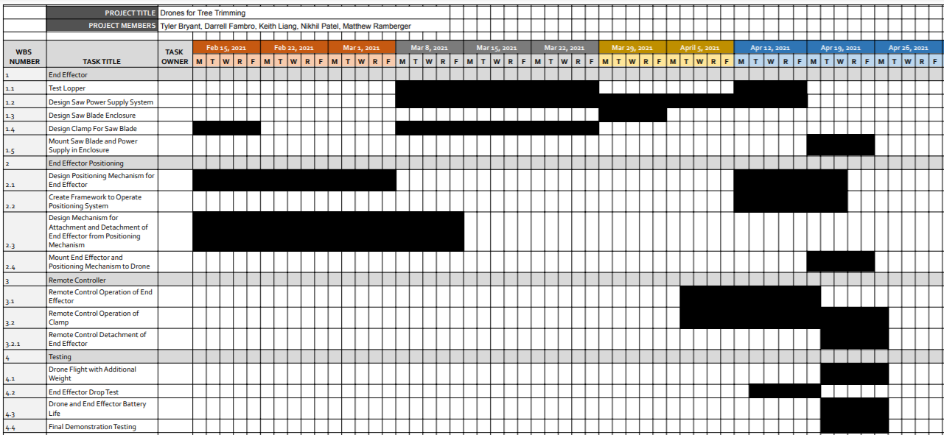

Appendix B - Project PERT Chart
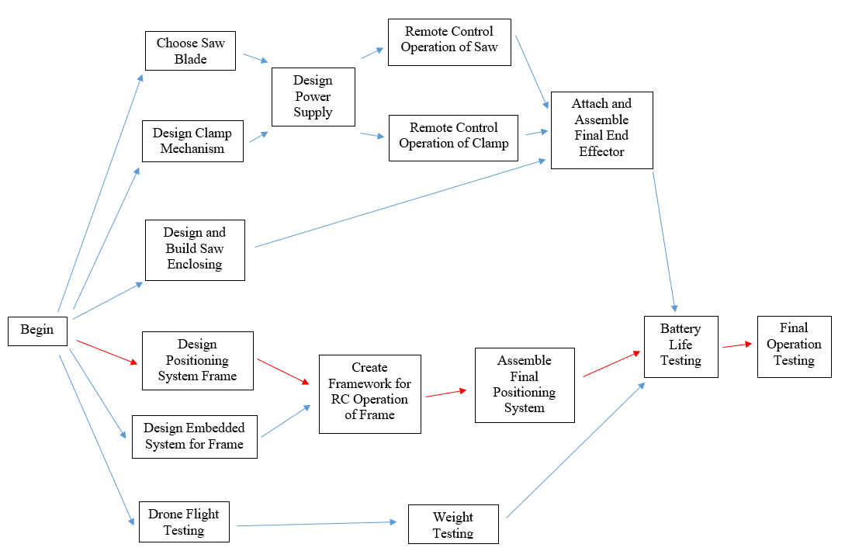

Appendix C - Scope of Work Document
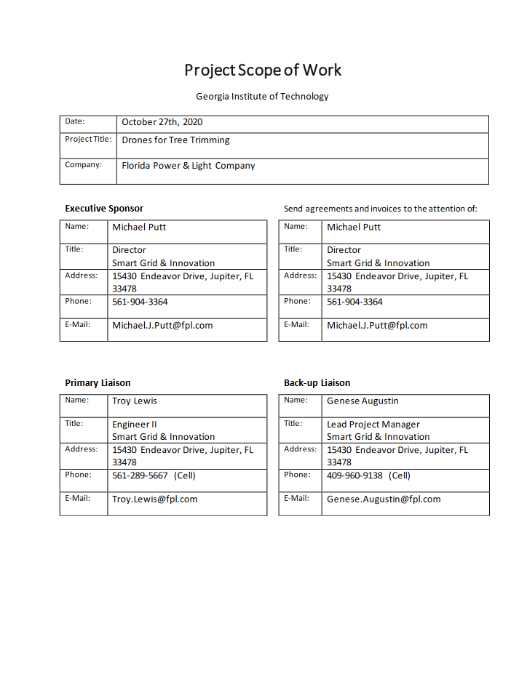

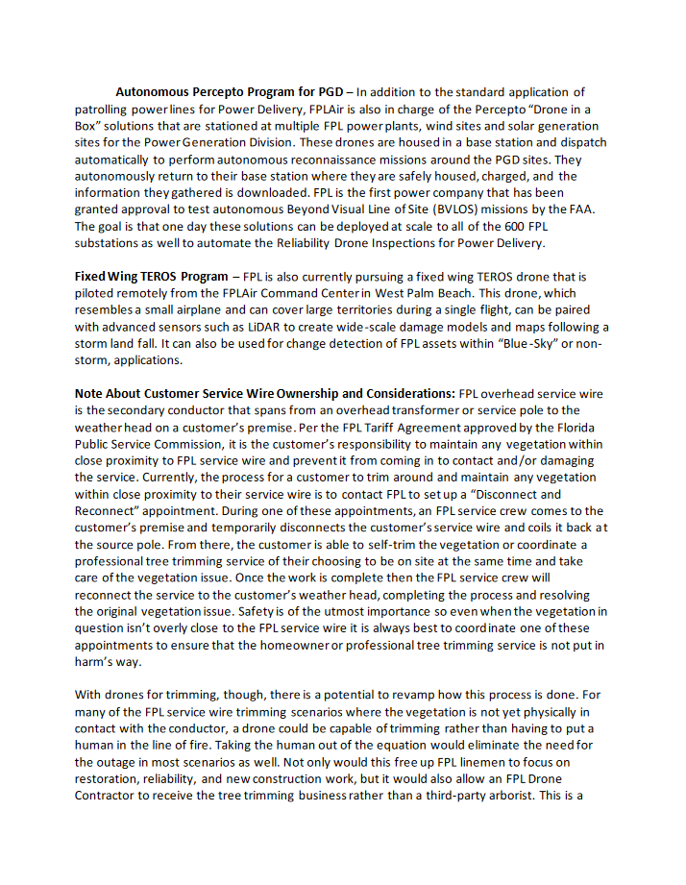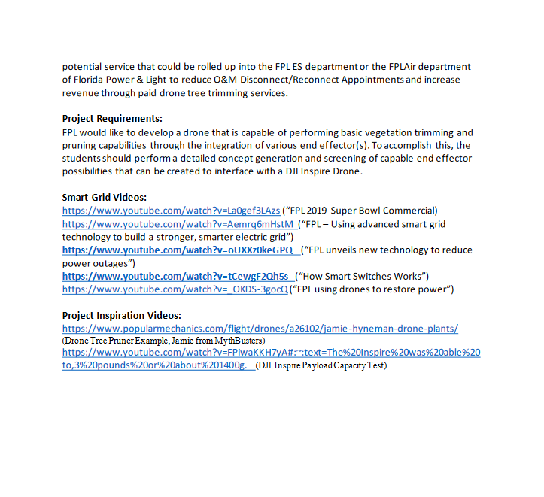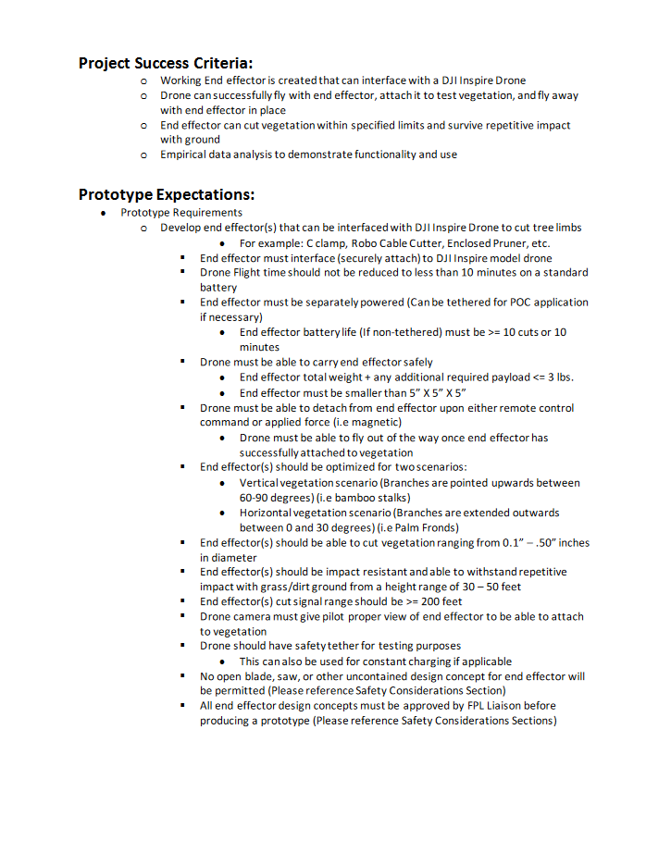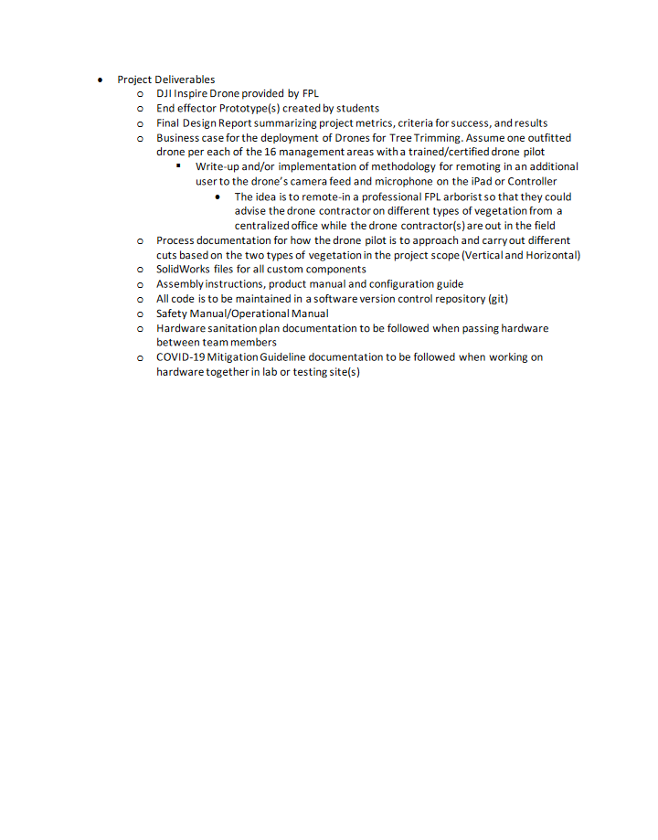
Appendix D - Software Flow Diagrams
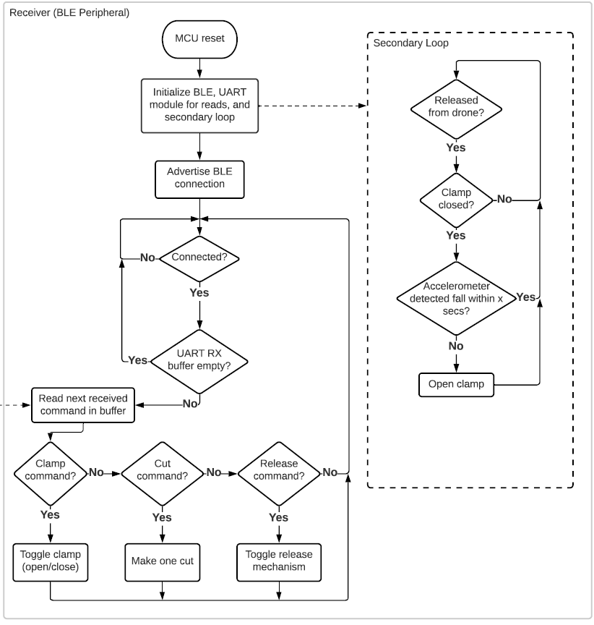
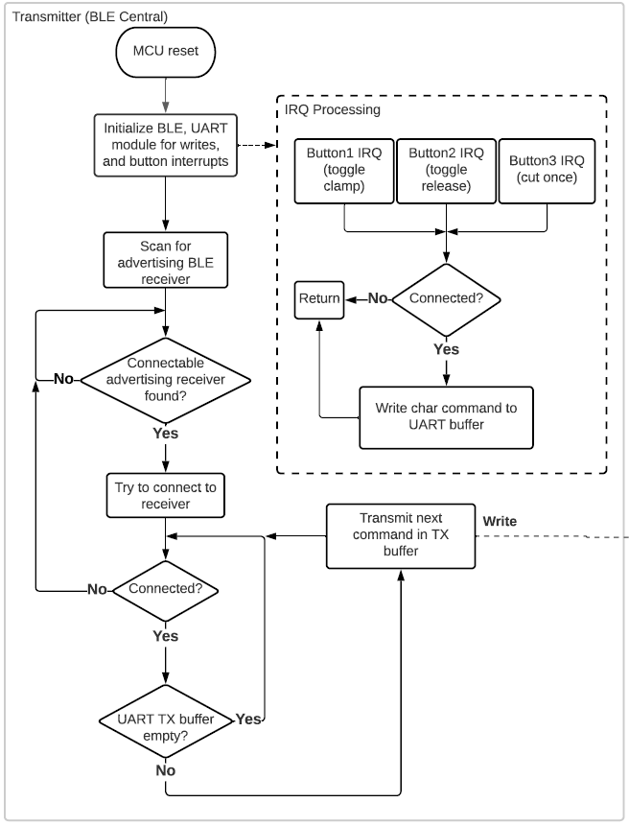
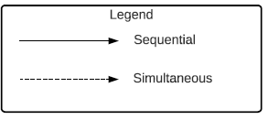

Appendix E - PCB Design
