**Drones for Tree Trimming**

ECE4872 Senior Design Project

Tree Trimmers

Advisor: Dr. James Kenney

Sponsor: Florida Power & Light

Matthew Ramberger, Electrical Engineering, mramberger3@gatech.edu

Nikhil Patel, Computer Engineering, nikhilp863@gatech.edu

Darrell Fambro, Computer Engineering, dfambro2@gatech.edu

Keith Liang, Electrical Engineering, kliang40@gatech.edu

Tyler Bryant, Electrical Engineering, tbryant9@gatech.edu

Submitted

2/19/21

**Table of Contents**

**Executive Summary (5 pts)**  iii

1. **Introduction (10 pts)**  1-3
   1. Objective 1
   2. Motivation 2
   3. Background 2-3
2. **Project Description and Goals (15 pts)**  3
3. **Technical Specification (15 pts)**  4
4. **Design Approach and Details (20 pts)** 5-16
   1. Design Approach 5-13

*System Overview* 5-6

*Power System* 7-8

*Microcontroller and Bluetooth* 8-9

*End-Effector Housing & Detachment* 9-11

*Clamping Mechanism* 11-12

*Cutting Mechanism* 12-13

*Software Design* 13

*Critical Path* 14

* 1. Constraints, Alternatives, and Tradeoffs 14-15
  2. Codes and Standards 15-16

1. **Project Demonstration (5 pts)** 17
2. **Schedule, Tasks, and Milestones (10 pts)**  17-18
3. **Marketing and Cost Analysis (5 pts)** 18-20
   1. Marketing Analysis 18
   2. Cost Analysis 18-20
4. **Current Status (5 pts)**  20
5. **Leadership Roles (5 pts)**  20-21
6. **References (5 pts)** 22-24

**Appendix A** 25

**Appendix B** 26

**Appendix C** 27-33

**Executive Summary**

Vegetation such as tree branches or bamboo stalks can potentially grow or fall into power lines causing outages. To prevent outages, the vegetation can be cut ahead of time. The Tree Trimmers team will be developing a removable attachment to a DJI Inspire drone that can cut small vegetation near power lines. The attachment will clamp on to a limb and disconnect from the drone. It will then cut the vegetation using an unexposed saw or a lopper, and the attachment will fall with the vegetation when cut. The attachment will have to clamp on and cut vertical vegetation ranging from +/- 30 degrees and horizontal vegetation ranging from +/- 30 degrees. The attachment will have to be powered enough to cut at least 10 branches of <.50 inches before running out of battery. The attachment will also have to have a signal range of over 200 feet and survive falls of up to 50 feet with no damage to it. A camera will have to be positioned to have proper view of the end effector and vegetation that it is attaching to. Safety wise, the end effector must have no open blades, and the drone must be tethered to prevent a flyaway drone scenario. The attachment, camera, and tether will have to weigh less than 3 pounds total or it will restrict the drone from moving properly.

There have been multiple drones that have been used to cut vegetation which already exist, but overall, they are unreliable and do not meet FPL's required performance specifications. The expected outcome of the design is a working prototype that will serve as a proof of concept for this field. The expected cost of making this device will be approximately $206.91.

**Quadcopter Reliability Drone for Vegetation Pruning**

**1. Introduction**

The Tree Trimmers Team will develop an end effector configuration for Florida Power & Light that can integrate with a DJI Inspire Drone in order to perform light trimming and pruning of vegetation. The team is requesting approximately $206.91 in order to develop this prototyped solution.

**1.1 Objective**

The team will design and prototype an optimal end effector configuration that can integrate with a DJI Inspire Drone in order to perform light trimming and pruning of vegetation surrounding power lines. A tethered DJI Inspire drone will contain a securely attached end effector that will approach vertical or horizontal vegetation. Once within close range of vegetation, the end effector will cut vegetation typically ranging between 0.1-.50 inches in diameter. The end effector will be impact resistant and will be able to withstand repetitive impact with grass and dirt from a height range of 30 -50 feet. In the event the end effector becomes entangled on a piece of vegetation, the end effector will disconnect from the drone, allowing the drone to safely fly away and return to the tethered area.

**1.2 Motivation**

Florida Power & Light is currently the largest energy company in the United States, providing service to more than 10 million people across the state of Florida. As the world largest generator in renewable energy from the wind and sun, FPL is proud to integrate the latest technology to build a smarter and stronger community. Because of this, the motivation for this product stems from FPL having the vision to implement the use of drones in order to provide safer and more reliable services to their customers in the area of removing vegetation in close proximity to service wire poles. Currently, the process in place requires customers to maintain responsibility to clear any vegetation within close proximity to FPL service wires. In cooperation with FPL, our team is determined to develop a prototype that will deploy to a customers home and clear the impending vegetation. By doing this, our team and FPL desire to introduce a safer option which results in the removal of FPL lineman from the line of fire. We also desire to bring vegetation-pruning contracts directly to FPL rather than customers using third-party arborists.

**1.3 Background**

Powered by the Smart Grid and Innovation group, FPL has a Florida Power & Light Aerial Intelligent Response (FPLAIR) department which oversees all aerial inspections of the company’s overhead transmission and distribution facilities in addition to multiple solar, wind, and combined cycle power plant sites. The specific use of drone technology in these aerial inspections gave birth to the idea of drone usage in vegetation pruning for customers. Florida suffers from severe weather seasons, with just last year Hurricane Dorian leaving approximately 160,000 customers without power and cost the company $374 million dollars in infrastructure damage [1]. As a result, FPL deployed new “drone in box” technology that can quickly focus on hard-to-reach spots up to 2 miles away, assessing damage in surrounding areas [2].

Known as the “Percepto Drone in Box” solutions, these drones are housed in a base station and dispatched automatically to perform autonomous reconnaissance missions near and around FPL sites. The drones were vigorously tested at Florida International University’s wind tunnel at speeds of up to 150 miles per hour, ensuring that even during storms these drones will prove to be effective. The drones are considered online 24 hours, 7 days a week, available for flight at a moments notice. After completing their missions, they return to their base stations where they are safely housed and charged. Their flight data is then downloaded, so what the drone saw can be analyzed.

Because of the FPL Tariff Agreement approved by the Florida Public Service Commission, which requires customers to maintain vegetation near FPL lines, customers are constantly having to reach out to professional tree clearing services in order to clear debris [3]. The potential involvement of FPLAIR and the drone our team develops poses a solution to this issue and furthermore creates an additional source of revenue for FPL through paid drone tree trimming services.

**2. Project Description, Customer Requirements, and Goals**

The fundamental goal of the Tree Trimmers team is to design and develop a drone that is capable of performing basic vegetation trimming and pruning capabilities through the integration of an effective end effector. The design will utilize the existing framing of a DJI Inspire Drone with an end effector that effectively cuts vegetation while limiting the impact of flight trajectory. The final project goals that would be considered a success include:

* Working end effector is created that can interface with a DJI Inspire Drone.
* Drone can successfully fly with end effector, attach it to test vegetation, and fly away with end effector in place .
* End effector can cut vegetation within specified limits and survive repeated falls onto grass or dirt.
* Empirical data analysis to demonstrate functionality and use.

1. **Technical Specifications**

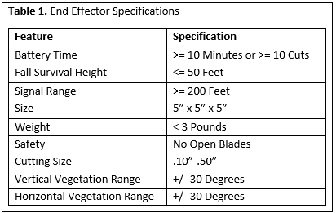

**Table 1.** Specifications and design requirements for the end effector. These specifications are required by Florida Power & Light.

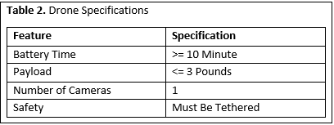

**Table 2.** Specifications and design requirements for the drone. These specifications are required by Florida Power & Light and the physical restraints of the DJI Inspire drone.

1. **Design Approach and Details**
   1. **Design Concept Ideation, Constraints, Alternatives, and Tradeoffs**

***System Overview***

The drone end-effector must complete the following functions:

* Clamp to the limb, whether vertical or horizontal. (0-30 degrees and 60-90 degrees from horizontal)

A clamp with sufficient clamping force to keep the end-effector attached to the branch while it is hanging and detached from the drone must be used.

* Detach remotely from the drone

This will use either a magnetic or mechanical release mechanism to detach and reattach the end-effector to the device. Weight will be the major consideration in which outlet is explored further.

* Allow the drone to fly away

The detachment process must be complete, no extra wires connecting the drone to the end-effector.

* Cut the limb

This will be performed by an on board motor, battery and pruning shear head. This option is the only foreseeable path, because of safety regulations given in the scope of work document provided by FPL and the material desired to be cut. (See Appendix C)

* Survive multiple falls from 30-50 feet

A 3D cage will be constructed to allow the end-effector to survive multiple falls.

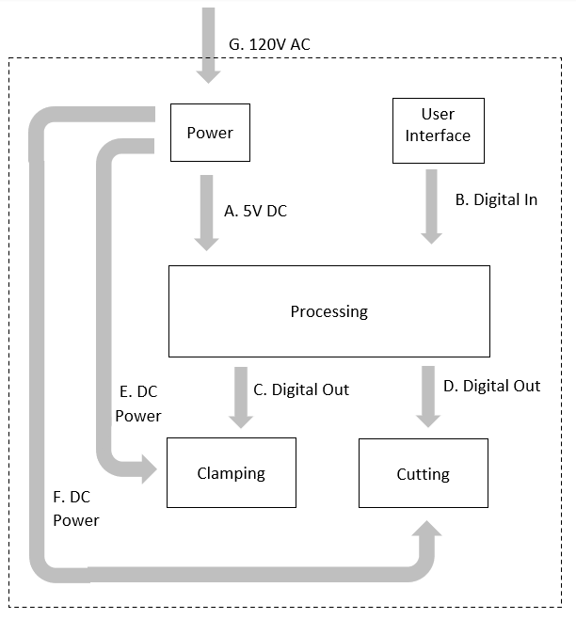

**Figure 1.** System block diagram of the end effector.

|  |  |  |  |
| --- | --- | --- | --- |
| Interface | Description | Source Sub-System | Destination Sub-System |
| 1. 5V DC | Microcontroller power supply. | Power | Processing |
| 1. Digital In | Digital inputs from push buttons on remote controller received by Bluetooth UART | User Interface | Processing |
| 1. Digital Out | Digital voltage signal for controlling clamp motors. | Processing | Clamping |
| 1. Digital Out | Digital voltage signal for controlling lopper motor. | Processing | Cutting |
| 1. DC Power | Clamp motor power supply | Power | Clamping |
| 1. DC Power | Lopper motor power supply | Power | Cutting |
| 1. 120 V AC | Wall power for recharging lithium-ion batteries. | N/A | Power |

**Table 3.** Interfaces between subsystems.

***Power System***

The power sub-system will consist of 3 3.7V lithium-ion batteries [6] connected in a battery pack, as well as a LD1117V33 voltage regulator. The LD1117V33 will be used to supply a constant 3.3V DC for powering the microcontroller.

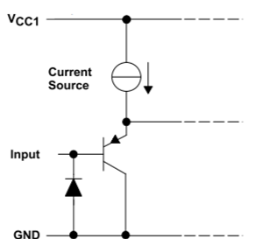

**Figure 2.** Motor driver input equivalent circuit.

The power sub-system will interface with an Adafruit Featherwing motor driver[14] with 4 input terminals will be used to drive currents for the lopper motors. When receiving user input, the microcontroller will output a digital voltage signal to the corresponding input terminal of the Featherwing, turning on the transistor in Figure 2 and driving current to the lopper motor. The clamp servo motors have built in motor drivers, and will directly receive digital input from the microcontroller. They will be powered with 5V DC from the battery pack.

The servo motor will also be powered by the battery pack. The chosen servo has a stall current of 0.8 A, and the battery pack contains 3 batteries rated at 2.5 Ah and capable of outputting 1.5 A currents. The battery will be able to supply enough current to the servo motor while the clamp is stalled for approximately 10 hours.

***Microcontroller and Bluetooth***

The microcontroller on the end-effector will serve to process command input communications from a remote controller and translate them into control signals that manipulate the cutting, clamping, and detachment mechanisms. To save the time necessary and complexity of developing a PCB to place the microcontroller on, a development board from Adafruit will be used. This board, the “Adafruit Feather nRF52840 Express” [13] uses the nRF52840 System on Chip (SoC), which combines a microcontroller and Bluetooth Low Energy (BLE) compatible module on a single chip [15]. Software development on the board will be done using the Arduino IDE or nRF5 SDK through the provided USB interface. A SWD connector is provided for debugging as well. The development board measures 51mm x 23mm and weights 6 grams, meaning it will not occupy much volume or weight capacity on the end-effector. It operates at 1.7 to 3.3 volts, with internal linear and DC/DC voltage regulators. The board has 21 GPIO pins, with I/O peripherals such as PWM, I2C, SPI, UART, timers, and a real-time clock, making it suitable for control applications. At 64 MHz, the ARM Cortex-M4F CPU used by the nRF52840 on the board is computationally fast enough for this simple control application and will not consume excess power. Finally, 1 MB of flash is very likely sufficient to store the program that will be written for it.

The nRF52840 SoC on the board uses the MDBT50Q module from Raytac. This is a Bluetooth 5.0 module, specifying working distances of at least 250 meters at 1MBps and 120 meters at 2MBps in open space [16], which satisfies our constraint of 200 feet (61 meters). Using long range (Coded PHY) mode, it can operate at longer distances at speeds of less than 500 Kbps. In addition, Adafruit has integrated the low level BLE stack before-hand, making the board easy to work with. The major benefit of using this Adafruit product is the ability to use the Bluefruit Connect iOS/Android app. This app allows for quick and easy communication with the Bluetooth module over BLE, allowing one to use a phone as a controller to send text encoded commands. Having access to such an application cuts down development time, removing the need to build a controller from scratch. This simplicity and ease of use is why Bluetooth is the preferred communication method over lower frequency RF communications, even though those methods have better range.

Another development board that was considered was the SparkFun Pro nRF52840 Mini [17], which offers very similar functionality as it also uses the nRF52840. This development board has much better documentation available. However, the fact that it is not compatible with the Bluefruit Connect app makes the Adafruit board the preferred choice.

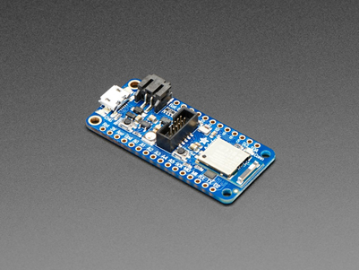

**Figure 2.** Adafruit Feather nRF52840 Express

***End-effector Housing & Detachment***

There are two housings being considered. Drop testing will determine which housing will be chosen for the final design. The first option is to 3D print at Georgia Tech’s Senior Design Labs. The filament we aspire to test with is polycarbonate-ABS alloy. While remaining light, polycarbonate-ABS is a strong material known for its impact resistance. The basic design is a webbed triangular prism with a half cylinder void in the bottom for the branch to rest in. The following picture gives a basic example of this design.

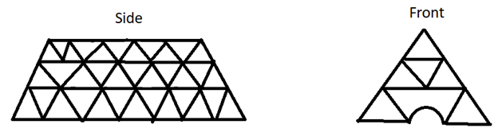

**Figure 3.** 3-D Printed Housing Design

The 3D printed cage may be difficult without the assignment of a mechanical engineer to our group. Therefore, we are developing an alternative solution to housing. Ordering pre-cut titanium pieces from a place like Prince Sheet Metal in Macon, GA, Tyler is capable of tig welding the pieces together to generate a box the same shape as the 3d printed design. Before welding the bottom of the box on we will mount the components in the box and fill with foam. This foam and using bushings to mount the components will allow for impact protection on all of the individual components inside the end effector. Flexible Foam by 3M will be used to fill all voids in the cavity. The only caveat is that titanium is relatively expensive.

Per Dr Kenney’s request we looked into T-slotted aluminum extrusions. However, this averages one pound per foot of material. While providing plenty of stability they are too heavy to consider in this design process. over half of the weight allotted for the end effector would be consumed in this design.

There are pre-existing products on the market that allow for remote detachment of a payload with DJI drones. After testing and determining which cage will be used in the final product, an appropriate 3rd party product will be purchased for detachment.

***Clamping Mechanism***

The end-effector must attach to a branch and disconnect from the drone before it cuts a branch. A clamping system will be used to attach to a branch. The end-effector will cut the branch once attached and fall to the ground with the branch. The clamp will be positioned on the side of the cutting mechanism so the end-effector will not stay attached to the tree once cut. The main clamp currently under consideration is the ACTOBOTICS Parallel Gripper Kit A shown in the figure below [11]. Since small branches down to .10” are being cut, we picked a clamp that didn’t have holes or places that could cause problems cutting small branches.

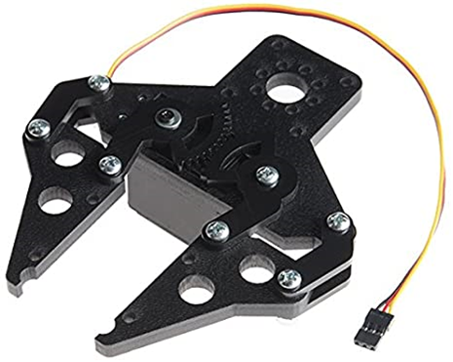

**Figure 4.** ACTOBOTICS Parallel Gripper Kit

This clamp is very light at 2.15 oz which is important considering the strict weight requirements. It has a maximum width of 2.80” which is more than the maximum branch diameter of .50 inches. This clamp also already has built in servo compatibility which will be required to control it. A servo will have to be purchased to control the clamp. One possibility is the Hitec 31311S HS-311 Servo, which weighs only 1.51 oz [12]. The servo will be powered by our power system described in a section above. In addition, nylon tape can be added to the gripping surface of the clamp to increase friction if needed.

Either one or two clamps can be used for connecting to the tree limbs. Two clamps seem better in theory if all the branches are straight, but most branches have splits or are curved, which can lead to one of the clamps not being connected to the tree or the cutting mechanism not reaching the branch. This could result in the end effector getting stuck on the branch and having to be retrieved manually. Furthermore, two clamps would take up lots of space and weight that we might not have. One clamp should be effective in securely connecting to a branch.

***Cutting Mechanism***

The cutting mechanism will be accomplished by driving a pair of shears found that have a gear drive. It could be necessary to cut the handles off and they will take some light modification, but the motor will easily connect to the pre-existing gear. As seen in the image below, the gear is easily accessible, and modifications will be simple.

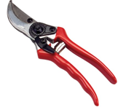

**Figure 5.** Shears showing the exposed gear mechanism

***Software Design***

The software design will follow a simple state machine concept allowing various states to be triggered depending upon certain inputs that will come from our remote controller. Currently, our design consists of a total of six states that describe the process form the powering on of the drone, to the completion of the cut.

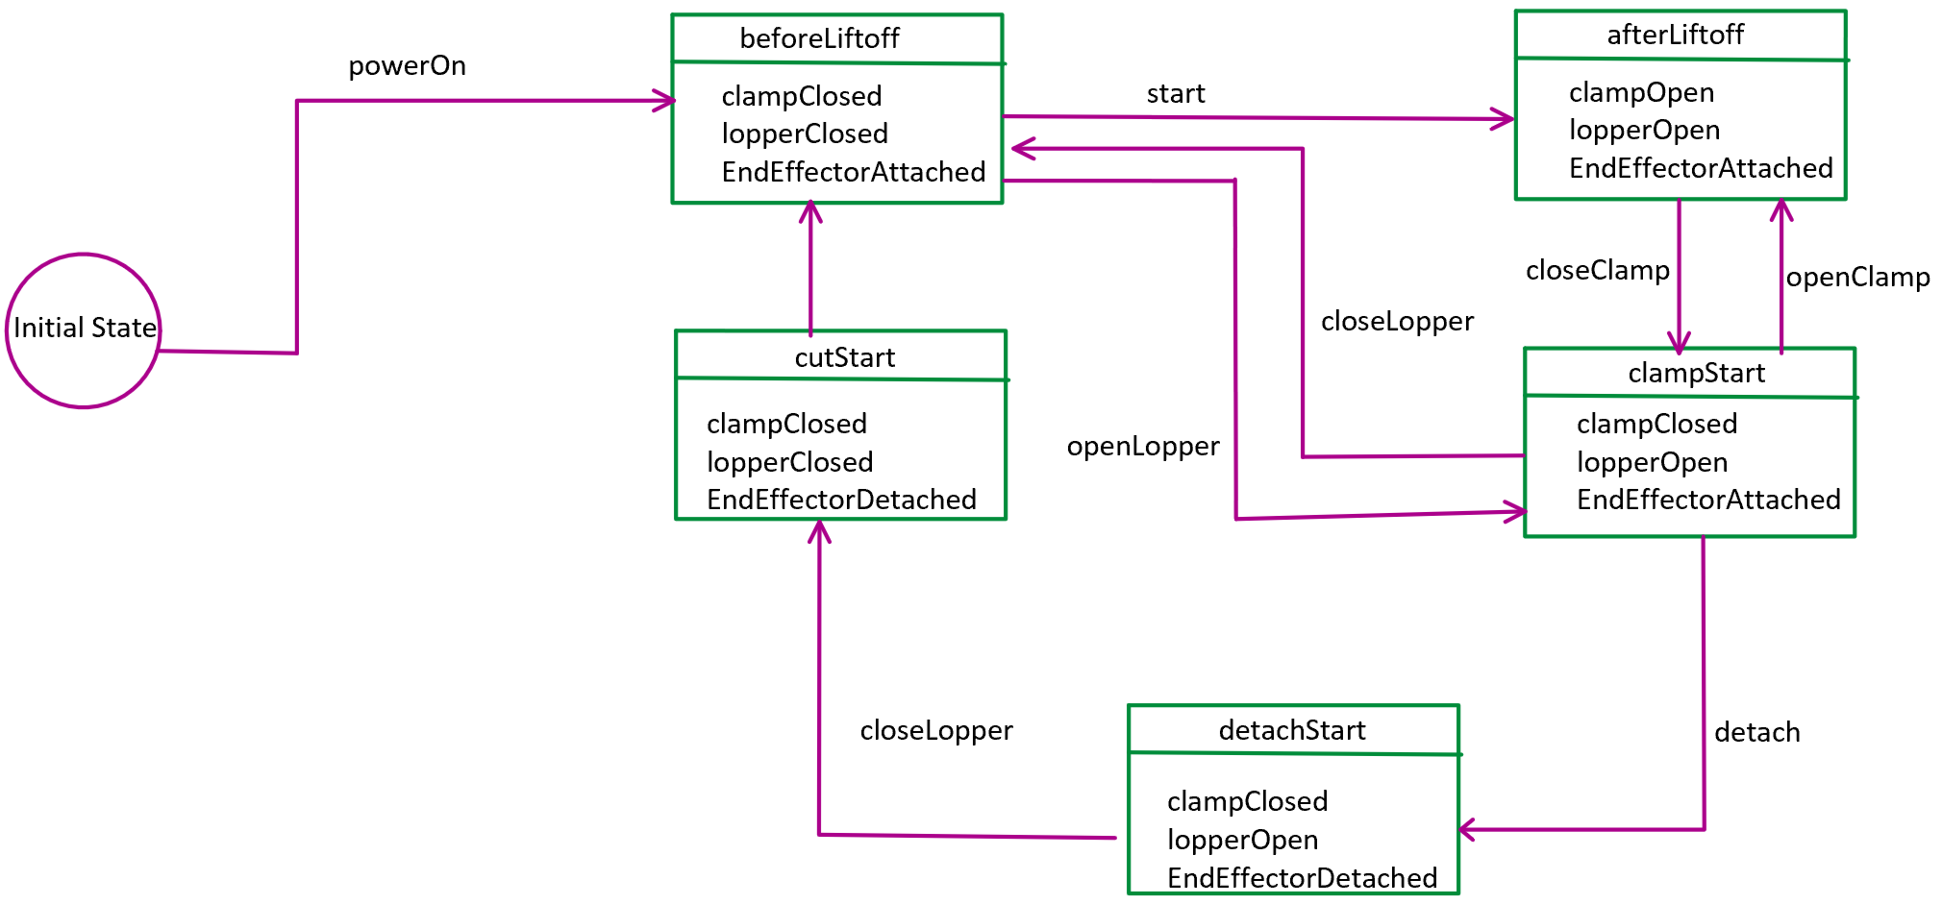

**Figure 6.** End-Effector State Machine

***Critical Path***

The largest time constraint will be the inability to test the cutting and clamping mechanisms with complete integration until the housing is complete. This develops the critical path of the project. To avoid future time constraints, building and drop testing the housing will be a primary focus.

* 1. **Constraints, Alternatives, and Tradeoffs**

The two limiting factors to the design are weight and power. It is observed from available batteries that 2.5 Ah @ 3.7V is available at 43g [6]. The total allotted weight for the end-effector is 3lbs or 1361g. The end-effector will require two geared motors, one to drive the clamp and the other to drive the shears. These 12V motors weigh 184g each, or 368g total [7]. A typical pair of shears also weighs 184g [8]. This puts the total weight at 552g, leaving 809g to be dedicated to batteries, framing, and the clamp. The motors will require at least 3 batteries to achieve the desired 12V for the motors. This will lower the total remaining weight to 680g. Barring any unforeseen circumstances this will be sufficient weight to distribute amongst framing and the clamp. The application of a pivot joint at the mounting mechanism will account for the displacement of the vertical and horizontal cuts.

A major computer engineering task will be integrating a control method for the end effector. This will require a remote controller aside from the normal one used to fly the drone. An onboard computer is absolutely necessary on the drone, namely the end-effector that will allow it to trim tree branches. The manual aspects of control need to be managed by this computer, in such a way that is reliable and responsive in real-time. In addition, a processor will be needed to interface between the human user and tree trimming extension. This means pulling communications data from a wireless communications module and translating them into commands in real-time.

The major tradeoff here is between power and performance. As drones are powered by batteries, they only have limited flight time before a recharge is needed. The DJI Inspire 1 has a normal flight time of 30 minutes. We don’t want to reduce this to under 10 minutes. A high performing processor would be able to handle all of our needs, but at the same time would require more power and reduce flight time. Thus, the goal is to choose a power efficient processor at some determined minimum performance specification.

* 1. **Codes and Standards**
* Bluetooth 5.0 - Bluetooth SIG oversees the Bluetooth wireless communication standard. Bluetooth is a protocol that exists to handle bluetooth communications in low power applications, and 5.0 is the latest version. Constraints and usage profiles in the standard, such as data transmission rates, range, and packet size will need to be considered. This will be used to communicate with the end-effector remotely at range.
* Drone is never to be used or tested within 500 feet of any energized overhead power line(s) or other hazardous structures
* The intent of this project is a proof of concept to show that a drone is capable of trimming vegetation. We do not expect or condone the students to actually attempt the trimming of any live vegetation and especially not of any live vegetation near energized power lines.
* All end effector prototypes must be submitted to FPL Liaison Engineer prior to fabrication for safety review and written approval
* Approved design considerations must employ an enclosed or shielded cutting method
* No open saw blades, sharp edges, rotating chains etc.
* Drone and/or end effector prototype must be tethered to a central ground anchor for safety considerations in order to prevent flyaway an establish a safe perimeter zone
* Testing apparatuses must also be submitted to FPL Liaison engineer for safety review and approval
* Approved testing apparatus design considerations must use pre-cut/already downed
* branches purchased from a suitable vegetation retailer and be mounted to a secure stand for testing purposes
* Testing must occur in a large open area free from traffic (both car and pedestrian), energized electrical facilities, and other obstructions
* Testing area must be in accordance with all FAA airspace restrictions
* Drone Operator, team members, and other Members of Public (MOP) should be
* Always restricted to well outside of tethered drone operation radius prior to and
* during testing
* Team must complete a standardized safety review (tailboard) with all person(s) present during testing before setting up testing apparatus and drone
* Team will keep a log of these safety reviews for reference and notify professor of all scheduled testing sessions
* Team will wear proper PPE prior to and during testing including but not limited to:
  + Hard Hat
  + Safety Glasses
  + Closed Toed Shoes
  + Long Sleeve shirt
  + Work Gloves (When handling vegetation, testing stand, and drone)

1. **Project Demonstration**

Following the safety considerations outlined in Appendix C This project will be demonstrated at an outdoors location that does not have restrictions on drones. This can be done anywhere with ample space for both the drone to fly and spectators to watch. Approximately, the drone will need a ten foot radius area of free space. If there is an audience, they will be positioned outside of this well marked area. Anyone within this area will be required to wear proper PPE: hard hat, safety glasses, closed toed shoes, long sleeve shirt, and work gloves (When handling vegetation, testing stand, and drone). The drone will also be tethered to the center of this circle to prevent any accidents if control of the drone is lost.

The drone will not fly above ten feet, in order to keep it easily visible during demonstration. In addition, the on-board video camera feed will be displayed to spectators. Trimming demonstrations will be performed on 0.5” diameter pre-cut or already downed branches purchased from a suitable vegetation retailer mounted to a secure stand. Unfortunately, some specifications of the drone such as range, battery life, and end effector drop resistance (dropping from 30-50 ft. near people is a safety concern) aren’t demonstrable in such a format; however the following four main features can and will be demonstrated:  
 1. Horizontal (0-30 deg.) vegetation (i.e. palm fronds) trimming, assisted by the on-board feed.

2. Vertical (60-90 deg.) vegetation (i.e. bamboo stalks) trimming, assisted by the on-board feed.

3. End effector detachment during cutting and ease-of reattachment afterwards.

4. Drone maneuverability with the added weight.

1. **Schedule, Tasks, and Milestones:**

The Gantt chart in Appendix A lists the tasks that will be completed, along with their schedules and owners. Each task has been allotted time proportional to its estimated difficulty.

The PERT chart in Appendix Bshows the order in which the tasks will be completed in. The critical path is highlighted with red arrows. The tasks along this path are predicted to be the riskiest and most time consuming because the team members have limited experience with robotics design and programming necessary to build a mechanism for positioning the end effector.

The physical design of the drone attachments is scheduled to be completed before spring break to provide 3 weeks of time for testing and improvements.

1. **Marketing and Cost Analysis**
   1. **Marketing Analysis**

This project is not intended to produce a marketable product, rather it is to create a proof of concept of a tool that will potentially be used by FPL internally. Therefore, it will not be sold, as it’s already owned by FPL. Outside of personal projects, there is nothing on the market or used industrially like what this project aims to create, a tree trimming drone. While there are plenty of drones out there, none have the additional capability of trimming vegetation. As such, this project is looking to lay down new groundwork.

* 1. **Cost Analysis**

The total material cost for a prototype of the drone end effector is approximately $206.91. A breakdown of the material costs of the prototype is shown in Table 3. The mechanical parts and motors used to drive them make up most of the expenses.

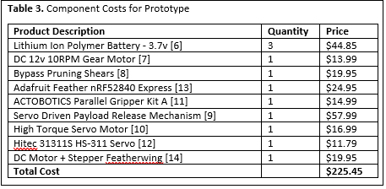

The development costs shown in Table 4 were determined using an assumed labor cost of $40 per hour and approximate part costs from Table 3. The testing and debugging portion will have the highest number of labor hours due to the complexity of the system’s hardware and mechanical parts, as well as the precision required to accomplish the drone’s task.

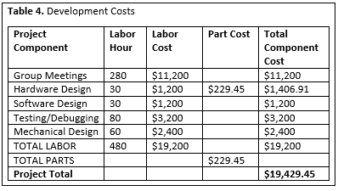

Using the fringe benefit as 30% of total labor and overhead as 120% of material and labor, the total development cost for the end effector is $55,365, shown in Table 5.

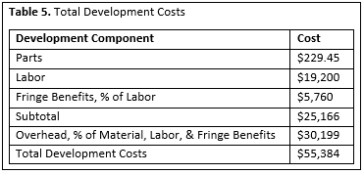

1. **Current Status**

At this point, we have communicated with FPL and received a scope of work document as well as the DJI Inspire drone that we will be working with. We have completed much of our early planning, though we have not yet gotten hands-on with any hardware. Our next goal is to solidify our design plans. This involves some experimentation, prototyping, and testing to determine what approach works the best in terms of cutting and end effector attach/detach mechanisms. Part of this is submitting order forms for all of the parts we need in advance. These important tasks will take place during ECE4872.

1. **Leadership Roles**

**Nikhil Patel** - Software Lead during ECE 4871, as well as Documentation Coordinator once ECE 4872 begins. Responsible for directing the development of team software, including setting up version control. Also responsible for ensuring all documentation is satisfactory and delivered on time during ECE4872.

**Matthew Ramberger** - Testing Team Lead during ECE 4871 and ECE 4872. Responsible for safely testing the end effector, measuring the performance of the drone and end effector, and coming up with solutions to problems found during testing for the project.

**Darrell Fambro** - Document editor for 4871, as well as Web Editor for 4872. Responsible for the review and editing of all documentation before submission.Also responsible for the design and implementation of the website detailing our project during 4872.

**Keith Liang** - Hardware Team Lead during ECE 4871 and Design Team Lead during ECE 4872. Responsible for management of hardware and mechanical design of end effector, positioning mechanism, and additional attachments to the drone.

**Tyler Bryant** - Director of Communications during ECE 4871 and ECE 4872, and Expo Coordinator during ECE 4872. Responsible for communicating team plans with FPL (industry) contacts and faculty advisers. Also responsible for making arrangements to demonstrate the prototype drone at the 2021 Capstone Design Expo.

1. **References**
2. M. McNabb and Miriam McNabbMiriam McNabb is the Editor-in-Chief of DRONELIFE and CEO of JobForDrones, “Drones in Hurricane Response: Florida Power and Light to Deploy Percepto's Sparrow,” *DRONELIFE*, 16-Jul-2020. [Online]. Available: https://dronelife.com/2020/07/16/percepto-drones-in-hurricane-response/. [Accessed: 13-Nov-2020].
3. M. Kenyon, “'Drone in a box' technology provides Florida Power & Light easier way to assess infrastructure,” *Treasure Coast*, 20-Feb-2020. [Online]. Available: https://www.tcpalm.com/story/news/2020/02/19/fpl-drone-box-another-tool-check-plant-infrastructure/4760778002/. [Accessed: 13-Nov-2020].
4. “Florida Public Service Commission,” *AssociatedDockets - Florida Public Service Commission*. [Online]. Available: http://www.psc.state.fl.us/ClerkOffice/AssociatedDockets?compcode=EI802. [Accessed: 14-Nov-2020].
5. “Parts & Accessories 1 Set Robot Clamp Mechanical Arm Manipulator Gripper Mechanical Paw for MG9969 Servo DIY RC Toy Robotics Remote Control”, *Amazon.com.* [Online]. Available: https://www.amazon.com/Accessories-Mechanical-Manipulator-Gripper-Robotics/dp/B089ZHBR1F?th=1&psc=1. [Accessed: Nov. 13, 2020].
6. “XBee 3 Module - PCB Antenna,” *Sparkfun.com*. [Online]. Available: https://www.sparkfun.com/products/15126. [Accessed: Nov. 13, 2020].
7. “Lithium Ion Polymer Battery - 3.7v 2500mAh,” *Adafruit.com.* [Online]. Available: http://www.adafruit.com/product/328. [Accessed: Nov. 13, 2020].
8. “Greartisan DC 12V 10RPM Gear Motor,” *Amazon.com.* [Online]. Available: https://www.amazon.com/Greartisan-Electric-Reduction-Centric-Diameter/dp/B089GTHGPZ/. [Accessed: Nov. 13, 2020].
9. “Gonnic 8” Professional Sharp Bypass Pruning Shears,” *Amazon.com.* [Online]. Available: https://www.amazon.com/gonicc-Professional-GPPS-1002-Trimmers-Secateurs/dp/B01HHK9JG6/. [Accessed: Nov. 13, 2020].
10. “RCGEEKClip Payload Delivery Airdrop Drone Drop Transport Double Release Thrower Device for Fishing Bait Released, Carrying Wedding Activities Gift,Search & Rescue Compatible with DJI Mavic 2 PRO/Zoom,” *Amazon.com.* [Online]. Available: https://www.amazon.com/RCGEEK-Delivery-Transport-Activities-Compatible/dp/B07VP3DRB5. [Accessed: Nov. 13, 2020].
11. “20KG Digital Servo Full Metal Gear High Torque, Aluminium Case for Robot DIY (Control Angle 180),” *Amazon.com.* [Online]. Available: https://www.amazon.com/LewanSoul-LD-20MG-Standard-Digital-Aluminium/dp/B073F92G2S/. [Accessed: Nov. 13, 2020].
12. “ACTOBOTICS Parallel Gripper Kit A,” *Amazon.com.* [Online]. Available: https://www.amazon.com/Actobotics-Parallel-Gripper-Kit-A/dp/B00OP2V5OY/ref. [Accessed Feb. 12, 2021].
13. “Hitec 31311S HS-311 Servo Standard Universal,” *Amazon.com.* [Online]. Available: https://www.amazon.com/Hitec-31311S-HS-311-Standard-Universal/dp/B0006O3WVE/ref. [Accessed Feb. 12, 2021].
14. “Adafruit Feather nRF52840 Express,” *Adafruit.com*. [Online]. Available: https://www.adafruit.com/product/4062#description. [Accessed Feb. 12, 2021]
15. “DC Motor + Stepper FeatherWing Add-On For All Feather Boards,” *Adafruit.com*. [Online]. Available: https://www.adafruit.com/product/2927. [Accessed Feb. 13, 2021]
16. “nRF52840,” *nordicsemi.com*. [Online]. Available: https://www.nordicsemi.com/Products/Low-power-short-range-wireless/nRF52840. [Accessed Feb. 13, 2021]
17. Raytac Corporation, “Approval Sheet,” MDBT50Q Datasheet, Jun. 12, 2018. [Onine]. Available: https://cdn-learn.adafruit.com/assets/assets/000/068/544/original/Raytac_MDBT50Q.pdf?1546346679. [Accessed: Feb. 13, 2021].
18. “SparkFun Pro nRF52840 Mini - Bluetooth Development Board,” *sparkfun.com*. [Online]. Available: https://www.sparkfun.com/products/15025. [Accessed Feb. 12, 2021]

**Appendix A - Project Gantt Chart**

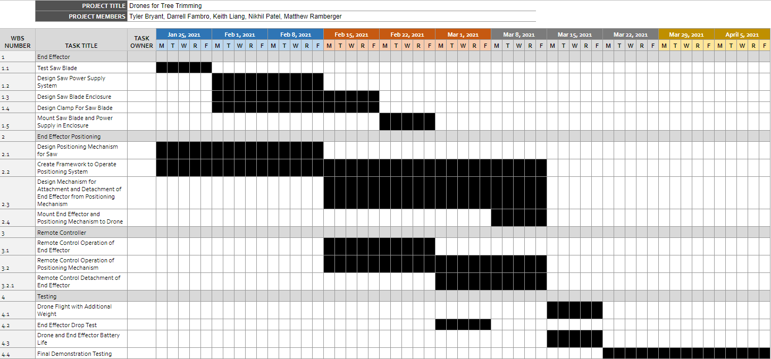

**Appendix B - Project PERT Chart**

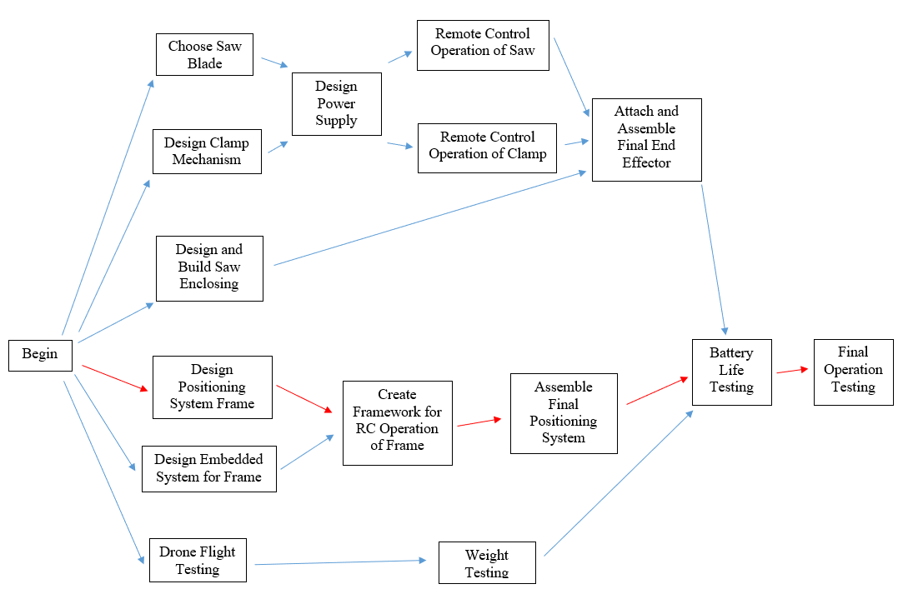

**Appendix C - Scope of Work Document**

